Supplementary Material: Frailty among older adults and its distribution in England

Appendix 1: Frailty index determinants

1a Local authority district level variables
Variable | Definition | Source | Year
Age | Mid-year age of population | Population projections for local authorities | 2020
Sex |  | Population projections for local authorities | 2020
Deprivation Index | English Index of Multiple Deprivation (IMD). Deprivation in quintiles | Index of Multiple Deprivation in quintile | 2019

1b Individual level predictors of frailty index
Variable | Definition | Code | Type
Age | The age of the respondent in the year of the survey | 50-54, 55-59, 60-64, 65-69, 70-74, 75-79, 80-84, 85-89, 90+ | Categorical
Sex | The sex of the respondent | 1=male  2=female | Nominal/binary
Deprivation Index | English Indices of Multiple Deprivation (IMD) 2015. Deprivation in quintiles. | 1-5 | Categorical

Appendix 2: Urban and Coastal designation of each local authority district. Urban designation is based on the Office of National Statistic’s 2011 rural-urban classification (1). Local authorities whose borders include foreshore (except within estuaries) are categorised as coastal.

LAD18CD | Local authority district | Urban and rural  classification | Coastal and inland  classification
E07000223 | Adur | URBAN | COASTAL
E07000026 | Allerdale | RURAL | COASTAL
E07000032 | Amber Valley | URBAN | INLAND
E07000224 | Arun | URBAN | COASTAL
E07000170 | Ashfield | URBAN | INLAND
E07000105 | Ashford | URBAN | INLAND
E07000200 | Babergh | RURAL | INLAND
E09000002 | Barking and Dagenham | URBAN | INLAND
E09000003 | Barnet | URBAN | INLAND
E08000016 | Barnsley | URBAN | INLAND
E07000027 | Barrow-in-Furness | URBAN | COASTAL
E07000066 | Basildon | URBAN | INLAND
E07000084 | Basingstoke and Deane | URBAN | INLAND
E07000171 | Bassetlaw | RURAL | INLAND
E06000022 | Bath and North East Somerset | URBAN | INLAND
E06000055 | Bedford | URBAN | INLAND
E09000004 | Bexley | URBAN | INLAND
E08000025 | Birmingham | URBAN | INLAND
E07000129 | Blaby | URBAN | INLAND
E06000008 | Blackburn with Darwen | URBAN | INLAND
E06000009 | Blackpool | URBAN | COASTAL
E07000033 | Bolsover | URBAN | INLAND
E08000001 | Bolton | URBAN | INLAND
E07000136 | Boston | URBAN | COASTAL
E06000058 | Bournemouth, Christchurch and Poole | URBAN | COASTAL
E06000036 | Bracknell Forest | URBAN | INLAND
E08000032 | Bradford | URBAN | INLAND
E07000067 | Braintree | RURAL | INLAND
E07000143 | Breckland | RURAL | INLAND
E09000005 | Brent | URBAN | INLAND
E07000068 | Brentwood | URBAN | INLAND
E06000043 | Brighton and Hove | URBAN | COASTAL
E06000023 | Bristol, City of | URBAN | INLAND
E07000144 | Broadland | URBAN | INLAND
E09000006 | Bromley | URBAN | INLAND
E07000234 | Bromsgrove | URBAN | INLAND
E07000095 | Broxbourne | URBAN | INLAND
E07000172 | Broxtowe | URBAN | INLAND
E10000002 | Buckinghamshire | URBAN | INLAND
E07000117 | Burnley | URBAN | INLAND
E08000002 | Bury | URBAN | INLAND
E08000033 | Calderdale | URBAN | INLAND
E07000008 | Cambridge | URBAN | INLAND
E09000007 | Camden | URBAN | INLAND
E07000192 | Cannock Chase | URBAN | INLAND
E07000106 | Canterbury | URBAN | COASTAL
E07000028 | Carlisle | URBAN | INLAND
E07000069 | Castle Point | URBAN | COASTAL
E06000056 | Central Bedfordshire | RURAL | INLAND
E07000130 | Charnwood | URBAN | INLAND
E07000070 | Chelmsford | URBAN | INLAND
E07000078 | Cheltenham | URBAN | INLAND
E07000177 | Cherwell | URBAN | INLAND
E06000049 | Cheshire East | URBAN | INLAND
E06000050 | Cheshire West and Chester | URBAN | INLAND
E07000034 | Chesterfield | URBAN | INLAND
E07000225 | Chichester | RURAL | COASTAL
E07000118 | Chorley | URBAN | INLAND
E09000001 | City of London | URBAN | INLAND
E07000071 | Colchester | URBAN | COASTAL
E07000029 | Copeland | RURAL | COASTAL
E07000150 | Corby | URBAN | INLAND
E06000052 | Cornwall | RURAL | COASTAL
E07000079 | Cotswold | RURAL | INLAND
E06000047 | County Durham | RURAL | COASTAL
E08000026 | Coventry | URBAN | INLAND
E07000163 | Craven | RURAL | INLAND
E07000226 | Crawley | URBAN | INLAND
E09000008 | Croydon | URBAN | INLAND
E07000096 | Dacorum | URBAN | INLAND
E06000005 | Darlington | URBAN | INLAND
E07000107 | Dartford | URBAN | INLAND
E07000151 | Daventry | RURAL | INLAND
E06000015 | Derby | URBAN | INLAND
E07000035 | Derbyshire Dales | RURAL | INLAND
E08000017 | Doncaster | URBAN | INLAND
E06000059 | Dorset | RURAL | COASTAL
E07000108 | Dover | URBAN | COASTAL
E08000027 | Dudley | URBAN | INLAND
E09000009 | Ealing | URBAN | INLAND
E07000009 | East Cambridgeshire | RURAL | INLAND
E07000040 | East Devon | RURAL | COASTAL
E07000085 | East Hampshire | RURAL | INLAND
E07000242 | East Hertfordshire | URBAN | INLAND
E07000137 | East Lindsey | RURAL | COASTAL
E07000152 | East Northamptonshire | RURAL | INLAND
E06000011 | East Riding of Yorkshire | RURAL | COASTAL
E07000193 | East Staffordshire | URBAN | INLAND
E07000244 | East Suffolk | RURAL | COASTAL
E07000061 | Eastbourne | URBAN | COASTAL
E07000086 | Eastleigh | URBAN | INLAND
E07000030 | Eden | RURAL | INLAND
E07000207 | Elmbridge | URBAN | INLAND
E09000010 | Enfield | URBAN | INLAND
E07000072 | Epping Forest | URBAN | INLAND
E07000208 | Epsom and Ewell | URBAN | INLAND
E07000036 | Erewash | URBAN | INLAND
E07000041 | Exeter | URBAN | INLAND
E07000087 | Fareham | URBAN | COASTAL
E07000010 | Fenland | RURAL | INLAND
E07000080 | Forest of Dean | RURAL | INLAND
E07000119 | Fylde | URBAN | COASTAL
E08000037 | Gateshead | URBAN | INLAND
E07000173 | Gedling | URBAN | INLAND
E07000081 | Gloucester | URBAN | INLAND
E07000088 | Gosport | URBAN | COASTAL
E07000109 | Gravesham | URBAN | INLAND
E07000145 | Great Yarmouth | URBAN | COASTAL
E09000011 | Greenwich | URBAN | INLAND
E07000209 | Guildford | URBAN | INLAND
E09000012 | Hackney | URBAN | INLAND
E06000006 | Halton | URBAN | INLAND
E07000164 | Hambleton | RURAL | INLAND
E09000013 | Hammersmith and Fulham | URBAN | INLAND
E07000131 | Harborough | RURAL | INLAND
E09000014 | Haringey | URBAN | INLAND
E07000073 | Harlow | URBAN | INLAND
E07000165 | Harrogate | URBAN | INLAND
E09000015 | Harrow | URBAN | INLAND
E07000089 | Hart | URBAN | INLAND
E06000001 | Hartlepool | URBAN | COASTAL
E07000062 | Hastings | URBAN | COASTAL
E07000090 | Havant | URBAN | COASTAL
E09000016 | Havering | URBAN | INLAND
E06000019 | Herefordshire, County of | RURAL | INLAND
E07000098 | Hertsmere | URBAN | INLAND
E07000037 | High Peak | RURAL | INLAND
E09000017 | Hillingdon | URBAN | INLAND
E07000132 | Hinckley and Bosworth | RURAL | INLAND
E07000227 | Horsham | RURAL | INLAND
E09000018 | Hounslow | URBAN | INLAND
E07000011 | Huntingdonshire | RURAL | INLAND
E07000120 | Hyndburn | URBAN | INLAND
E07000202 | Ipswich | URBAN | INLAND
E06000046 | Isle of Wight | RURAL | COASTAL
E06000053 | Isles of Scilly | RURAL | COASTAL
E09000019 | Islington | URBAN | INLAND
E09000020 | Kensington and Chelsea | URBAN | INLAND
E07000153 | Kettering | URBAN | INLAND
E07000146 | King's Lynn and West Norfolk | RURAL | COASTAL
E06000010 | Kingston upon Hull, City of | URBAN | INLAND
E09000021 | Kingston upon Thames | URBAN | INLAND
E08000034 | Kirklees | URBAN | INLAND
E08000011 | Knowsley | URBAN | INLAND
E09000022 | Lambeth | URBAN | INLAND
E07000121 | Lancaster | URBAN | COASTAL
E08000035 | Leeds | URBAN | INLAND
E06000016 | Leicester | URBAN | INLAND
E07000063 | Lewes | URBAN | COASTAL
E09000023 | Lewisham | URBAN | INLAND
E07000194 | Lichfield | URBAN | INLAND
E07000138 | Lincoln | URBAN | INLAND
E08000012 | Liverpool | URBAN | INLAND
E06000032 | Luton | URBAN | INLAND
E07000110 | Maidstone | URBAN | INLAND
E07000074 | Maldon | RURAL | COASTAL
E07000235 | Malvern Hills | RURAL | INLAND
E08000003 | Manchester | URBAN | INLAND
E07000174 | Mansfield | URBAN | INLAND
E06000035 | Medway | URBAN | INLAND
E07000133 | Melton | RURAL | INLAND
E07000187 | Mendip | RURAL | INLAND
E09000024 | Merton | URBAN | INLAND
E07000042 | Mid Devon | RURAL | INLAND
E07000203 | Mid Suffolk | RURAL | INLAND
E07000228 | Mid Sussex | URBAN | INLAND
E06000002 | Middlesbrough | URBAN | INLAND
E06000042 | Milton Keynes | URBAN | INLAND
E07000210 | Mole Valley | URBAN | INLAND
E07000091 | New Forest | URBAN | COASTAL
E07000175 | Newark and Sherwood | RURAL | INLAND
E08000021 | Newcastle upon Tyne | URBAN | INLAND
E07000195 | Newcastle-under-Lyme | URBAN | INLAND
E09000025 | Newham | URBAN | INLAND
E07000043 | North Devon | RURAL | COASTAL
E07000038 | North East Derbyshire | URBAN | INLAND
E06000012 | North East Lincolnshire | URBAN | INLAND
E07000099 | North Hertfordshire | URBAN | INLAND
E07000139 | North Kesteven | RURAL | INLAND
E06000013 | North Lincolnshire | URBAN | INLAND
E07000147 | North Norfolk | RURAL | COASTAL
E06000024 | North Somerset | URBAN | COASTAL
E08000022 | North Tyneside | URBAN | COASTAL
E07000218 | North Warwickshire | RURAL | INLAND
E07000134 | North West Leicestershire | RURAL | INLAND
E07000154 | Northampton | URBAN | INLAND
E06000057 | Northumberland | RURAL | COASTAL
E07000148 | Norwich | URBAN | INLAND
E06000018 | Nottingham | URBAN | INLAND
E07000219 | Nuneaton and Bedworth | URBAN | INLAND
E07000135 | Oadby and Wigston | URBAN | INLAND
E08000004 | Oldham | URBAN | INLAND
E07000178 | Oxford | URBAN | INLAND
E07000122 | Pendle | URBAN | INLAND
E06000031 | Peterborough | URBAN | INLAND
E06000026 | Plymouth | URBAN | COASTAL
E06000044 | Portsmouth | URBAN | COASTAL
E07000123 | Preston | URBAN | INLAND
E06000038 | Reading | URBAN | INLAND
E09000026 | Redbridge | URBAN | INLAND
E06000003 | Redcar and Cleveland | URBAN | COASTAL
E07000236 | Redditch | URBAN | INLAND
E07000211 | Reigate and Banstead | URBAN | INLAND
E07000124 | Ribble Valley | RURAL | INLAND
E09000027 | Richmond upon Thames | URBAN | INLAND
E07000166 | Richmondshire | RURAL | INLAND
E08000005 | Rochdale | URBAN | INLAND
E07000075 | Rochford | URBAN | COASTAL
E07000125 | Rossendale | URBAN | INLAND
E07000064 | Rother | RURAL | COASTAL
E08000018 | Rotherham | URBAN | INLAND
E07000220 | Rugby | URBAN | INLAND
E07000212 | Runnymede | URBAN | INLAND
E07000176 | Rushcliffe | RURAL | INLAND
E07000092 | Rushmoor | URBAN | INLAND
E06000017 | Rutland | RURAL | INLAND
E07000167 | Ryedale | RURAL | INLAND
E08000006 | Salford | URBAN | INLAND
E08000028 | Sandwell | URBAN | INLAND
E07000168 | Scarborough | URBAN | COASTAL
E07000188 | Sedgemoor | RURAL | COASTAL
E08000014 | Sefton | URBAN | COASTAL
E07000169 | Selby | RURAL | INLAND
E07000111 | Sevenoaks | RURAL | INLAND
E08000019 | Sheffield | URBAN | INLAND
E07000112 | Shepway | URBAN | COASTAL
E06000051 | Shropshire | RURAL | INLAND
E06000039 | Slough | URBAN | INLAND
E08000029 | Solihull | URBAN | INLAND
E07000246 | Somerset West and Taunton | RURAL | COASTAL
E07000012 | South Cambridgeshire | RURAL | INLAND
E07000039 | South Derbyshire | URBAN | INLAND
E06000025 | South Gloucestershire | URBAN | INLAND
E07000044 | South Hams | RURAL | COASTAL
E07000140 | South Holland | RURAL | COASTAL
E07000141 | South Kesteven | RURAL | INLAND
E07000031 | South Lakeland | RURAL | COASTAL
E07000149 | South Norfolk | RURAL | INLAND
E07000155 | South Northamptonshire | RURAL | INLAND
E07000179 | South Oxfordshire | RURAL | INLAND
E07000126 | South Ribble | URBAN | INLAND
E07000189 | South Somerset | RURAL | INLAND
E07000196 | South Staffordshire | URBAN | INLAND
E08000023 | South Tyneside | URBAN | COASTAL
E06000045 | Southampton | URBAN | INLAND
E06000033 | Southend-on-Sea | URBAN | COASTAL
E09000028 | Southwark | URBAN | INLAND
E07000213 | Spelthorne | URBAN | INLAND
E07000240 | St Albans | URBAN | INLAND
E08000013 | St. Helens | URBAN | INLAND
E07000197 | Stafford | URBAN | INLAND
E07000198 | Staffordshire Moorlands | RURAL | INLAND
E07000243 | Stevenage | URBAN | INLAND
E08000007 | Stockport | URBAN | INLAND
E06000004 | Stockton-on-Tees | URBAN | INLAND
E06000021 | Stoke-on-Trent | URBAN | INLAND
E07000221 | Stratford-on-Avon | RURAL | INLAND
E07000082 | Stroud | URBAN | INLAND
E08000024 | Sunderland | URBAN | COASTAL
E07000214 | Surrey Heath | URBAN | INLAND
E09000029 | Sutton | URBAN | INLAND
E07000113 | Swale | RURAL | COASTAL
E06000030 | Swindon | URBAN | INLAND
E08000008 | Tameside | URBAN | INLAND
E07000199 | Tamworth | URBAN | INLAND
E07000215 | Tandridge | URBAN | INLAND
E07000045 | Teignbridge | RURAL | COASTAL
E06000020 | Telford and Wrekin | URBAN | INLAND
E07000076 | Tendring | RURAL | COASTAL
E07000093 | Test Valley | URBAN | INLAND
E07000083 | Tewkesbury | RURAL | INLAND
E07000114 | Thanet | URBAN | COASTAL
E07000102 | Three Rivers | URBAN | INLAND
E06000034 | Thurrock | URBAN | INLAND
E07000115 | Tonbridge and Malling | URBAN | INLAND
E06000027 | Torbay | URBAN | COASTAL
E07000046 | Torridge | RURAL | COASTAL
E09000030 | Tower Hamlets | URBAN | INLAND
E08000009 | Trafford | URBAN | INLAND
E07000116 | Tunbridge Wells | URBAN | INLAND
E07000077 | Uttlesford | RURAL | INLAND
E07000180 | Vale of White Horse | RURAL | INLAND
E08000036 | Wakefield | URBAN | INLAND
E08000030 | Walsall | URBAN | INLAND
E09000031 | Waltham Forest | URBAN | INLAND
E09000032 | Wandsworth | URBAN | INLAND
E06000007 | Warrington | URBAN | INLAND
E07000222 | Warwick | URBAN | INLAND
E07000103 | Watford | URBAN | INLAND
E07000216 | Waverley | RURAL | INLAND
E07000065 | Wealden | RURAL | COASTAL
E07000156 | Wellingborough | URBAN | INLAND
E07000241 | Welwyn Hatfield | URBAN | INLAND
E06000037 | West Berkshire | URBAN | INLAND
E07000047 | West Devon | RURAL | INLAND
E07000127 | West Lancashire | URBAN | INLAND
E07000142 | West Lindsey | RURAL | INLAND
E07000181 | West Oxfordshire | RURAL | INLAND
E07000245 | West Suffolk | RURAL | INLAND
E09000033 | Westminster | URBAN | INLAND
E08000010 | Wigan | URBAN | INLAND
E06000054 | Wiltshire | RURAL | INLAND
E07000094 | Winchester | RURAL | INLAND
E06000040 | Windsor and Maidenhead | URBAN | INLAND
E08000015 | Wirral | URBAN | COASTAL
E07000217 | Woking | URBAN | INLAND
E06000041 | Wokingham | URBAN | INLAND
E08000031 | Wolverhampton | URBAN | INLAND
E07000237 | Worcester | URBAN | INLAND
E07000229 | Worthing | URBAN | COASTAL
E07000238 | Wychavon | RURAL | INLAND
E07000128 | Wyre | RURAL | COASTAL
E07000239 | Wyre Forest | URBAN | INLAND
E06000014 | York | URBAN | INLAND

Appendix 2: Variables included in the frailty index from the English Longitudinal Survey of Ageing (ELSA) (2).

No | Variable
Mobility
1 | Difficulty walking 100 yards
2 | Difficulty sitting for 2 hours
3 | Difficulty getting up from chair after sitting long periods
4 | Difficulty climbing several flights stairs without resting
5 | Difficulty climbing one flight stairs without resting
6 | Difficulty stooping, kneeling, or crouching
7 | Difficulty reaching or extending arms above shoulder level
8 | Difficulty pulling or pushing large objects
9 | Difficulty lifting or carrying weights over 10 pounds
10 | Difficulty picking up 5p coin from the table
Activities Daily Living (ADL)
11 | Difficulty dressing, including putting on shoes and socks
12 | Difficulty walking across the room
13 | Difficulty bathing or showering
14 | Difficulty eating, such as cutting up food
15 | Difficulty getting in and out of bed
16 | Difficulty using the toilet, including getting up or down
Instrumental Activities Daily Living (IADL)
17 | Difficulty using map to figure out how to get around strange
18 | Difficulty preparing a hot meal
19 | Difficulty shopping for groceries
20 | Difficulty making telephone calls
21 | Difficulty taking medications
22 | Difficulty managing money, such as paying bills and keeping tracks of expenses
23 | Difficulty doing work around the house or garden
Self-reported general health
24 | Self-reported general health
Ever diagnosed by health professionals
25 | Hypertension
26 | Angina
27 | Heart attack
28 | Congestive heart failure
29 | Abnormal heart rhythm
30 | Diabetes/high blood sugar
31 | Stroke
32 | Lung diseases
33 | Asthma
34 | Arthritis
35 | Osteoporosis
36 | Cancer
37 | Parkinson diseases
38 | Psychiatric conditions
39 | Alzheimer diseases
40 | Dementia
Subjective sensory function
41 | Poor or fair self-reported eyesight
42 | Poor or fair self-reported hearing
Falls and other health issues
43 | Fallen down
44 | Fractured hip
45 | Had joint replacement
Cognitive function
46 | Cannot answer correct day of month
47 | Cannot answer correct month
48 | Cannot answer correct year
49 | Cannot answer correct day
50 | Immediate recall
51 | Delayed recall

All binary variables are recoded, using the convention that ‘0’ indicates absence and ‘1’ presence of a deficit. Deficit points are summed for each individual, and divided by the total number of deficits, to produce a frailty index with a range from 0 to 1.

Appendix 3: Pre-frailty results and discussion

Prevalence of pre-frailty among people age 50+ was 9.9% [95% CI 9.1-10.6]. Estimates were higher for women (pre-frailty: 11.0 [9.9-12.0]%) than men (pre-frailty: 8.7 [7.6-9.7]%). Appendix Table 3a indicates how sex-specific estimates of pre-frailty and frailty varies with age. Like frailty, the prevalence of pre-frailty increases steeply with advancing age. However, the expected prevalence of pre-frailty peaks in the 85-89 year old age group. The lower value for people aged 90+ may be explained by the increased prevalence of the frailty among people aged 90+; as the proportion of people who are frail increases, the proportion of people who are robust and pre-frail must eventually start decreasing.

Among local authorities, the lowest pre-frailty prevalence of people aged 50 and over is 6.3 [5.8-6.8]%, and the highest is 16.6 [15.5-17.8]%, a factor of 2.7 [2.4-2.9] difference.

These small-areas estimates of pre-frailty prevalence could be used to target interventions aimed at delaying the onset of frailty. This may be especially useful in areas which already have large pre-frail populations, as increases in the size of the frail population may see increased demand on health and care services.

Appendix 3a: Estimated pre-frailty prevalence in 2020 by sex and age using ordered logistic regression model calculated from ELSA wave 8 data. 95% confidence intervals (CI) given.
Age group | All (%, CI) | Male (%, CI) | Females (%, CI)
Pre-frailty
50-54 | 4.3 (1.7-6.9) | 3.5 (1.3-5.8) | 5.0 (1.9-8.1)
55-59 | 3.0 (1.6-4.4) | 2.4 (1.1-3.7) | 3.5 (1.8-5.1)
60-64 | 6.7 (5.2-8.2) | 5.6 (4.2-7.1) | 7.7 (5.9-9.5)
65-69 | 8.2 (6.6-9.7) | 6.9 (5.3-8.5) | 9.3 (7.5-11.1)
70-74 | 12.4 (10.5-14.3) | 10.7 (8.7-12.6) | 14.0 (11.7-16.2)
75-80 | 15.7 (13.3-18.1) | 13.7 (11.3-16.1) | 17.4 (14.7-20.2)
80-84 | 20.7 (17.6-23.8) | 18.6 (15.3-21.8) | 22.6 (19.1-26.1)
85-89 | 29.5 (24.3-34.7) | 27.8 (22.3-33.4) | 31.0 (25.6-36.4)
90+ | 27.0 (19.0-35.0) | 26.9 (18.4-35.4) | 27.1 (19.1-35.2)
50+ | 9.9 (9.1-10.6) | 8.7 (7.6-9.7) | 11.0 (9.9-12.0)
Frailty
50-54 | 2.8 (0.8-4.7) | 2.3 (0.6-4.0) | 3.2 (1.0-5.4)
55-59 | 4.3 (2.3-6.3) | 3.6 (2.0-5.2) | 4.9 (2.5-7.3)
60-64 | 6.8 (5.3-8.4) | 5.8 (4.3-7.2) | 7.8 (5.9-9.7)
65-69 | 6.0 (4.7-7.3) | 5.0 (3.7-6.3) | 6.9 (5.3-8.4)
70-74 | 7.9 (6.3-9.5) | 6.7 (5.1-8.3) | 9.0 (7.1-11.0)
75-80 | 10.0 (7.9-12.1) | 8.5 (6.4-10.5) | 11.4 (8.9-13.9)
80-84 | 13.9 (11.3-16.6) | 11.9 (9.1-14.7) | 15.7 (12.7-18.8)
85-89 | 22.9 (18.1-27.7) | 20.0 (15.0-25.0) | 25.5 (20.4-30.7)
90+ | 40.8 (32.3-49.4) | 36.9 (28.0-45.8) | 44.4 (35.5-53.3)
50+ | 8.1 (7.3-8.8) | 6.8 (5.9-7.8) | 9.1 (8.0-10.1)

Appendix 3b: Prevalence of pre-frailty and frailty among over 50s in among different local authority district area types. All local authority districts are categorised as either rural or urban, and either inland or coastal. Rural-inland shows areas that are both rural and inland; similarly for urban-inland, rural-coast and urban-coast. Boxes indicate the 25th to 75th percentiles, notches the uncertainty on the median, and whiskers the largest/smallest value no further than 1.5 times the interquartile range above/below each box. Dots indicate outliers from the whiskers.
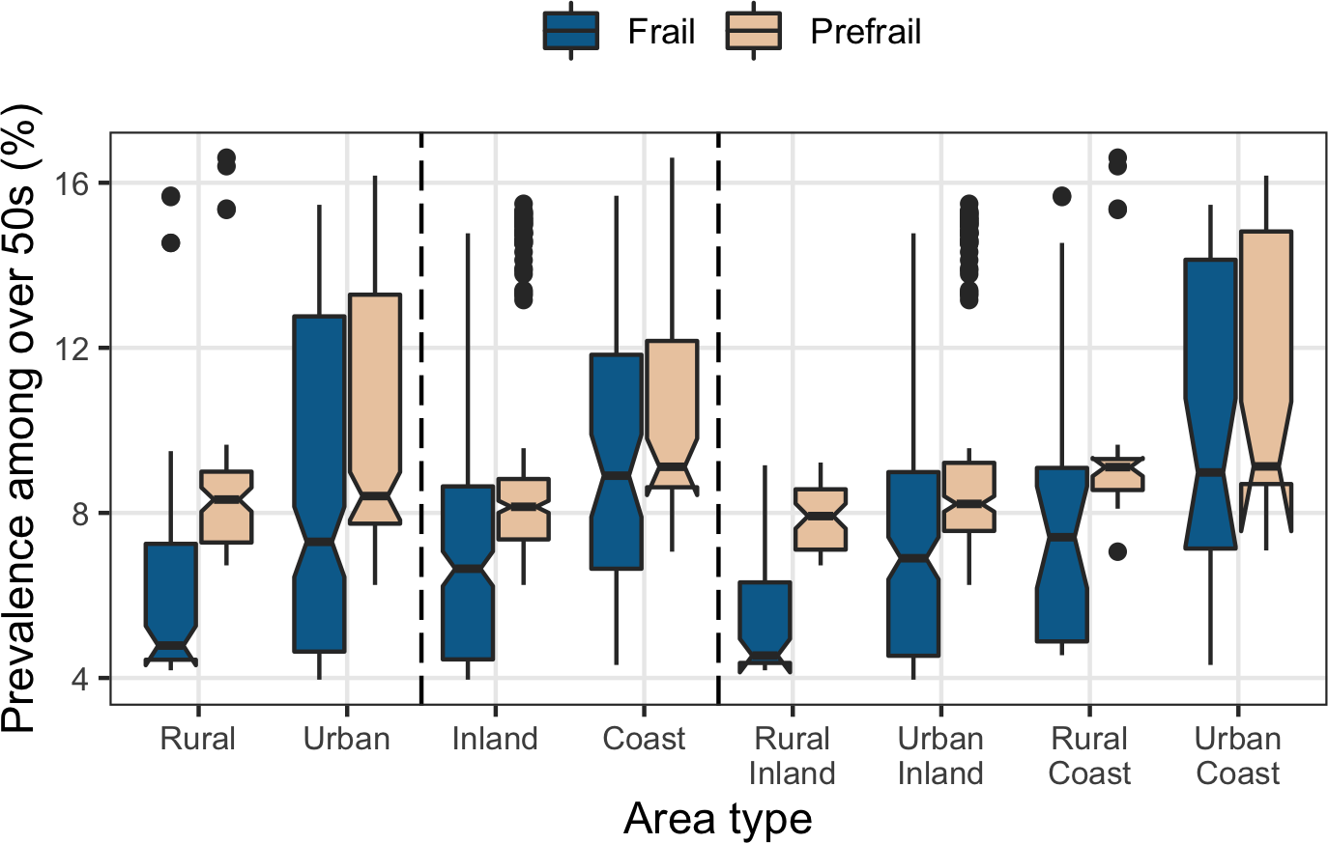
Appendix 3c: Risk ratio of being pre-frail and frail in (left) urban, relative to rural and (right) in coastal, relative to inland, local authority districts. Risk ratios are calculated using median prevalence of local authority districts in each area type.
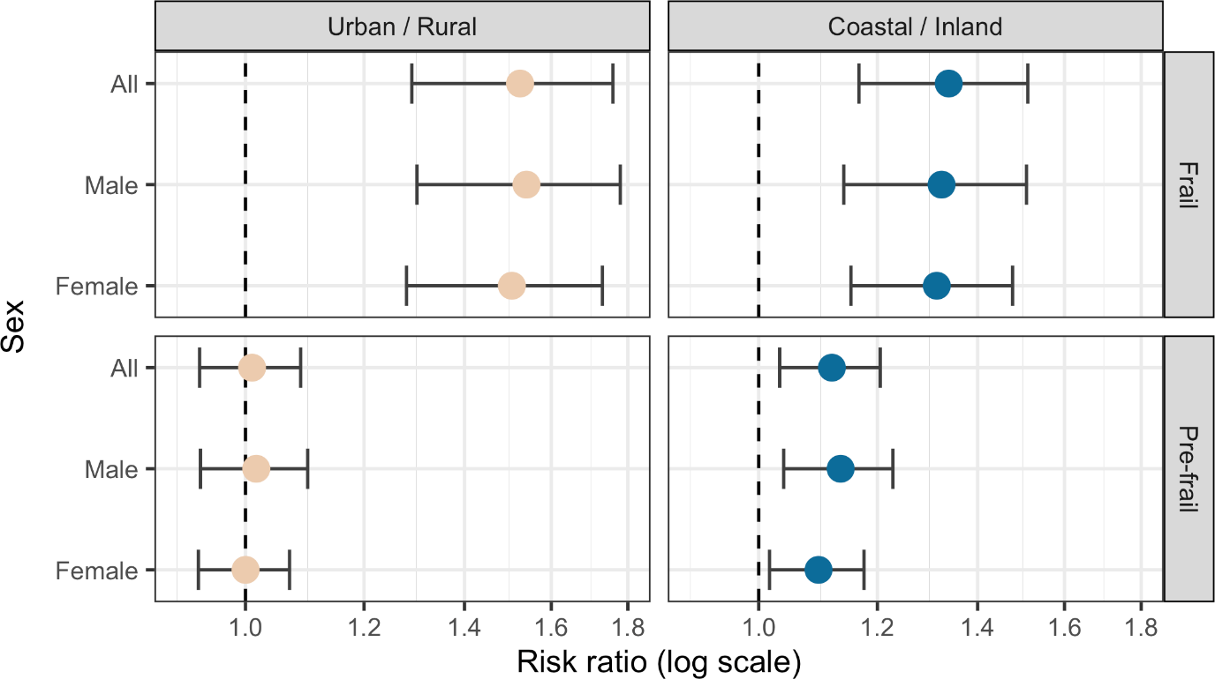

Appendix 4: Detailed methods

Area measures
The small area estimation methodology requires covariate data to be available on a geography compatible with LADs. Population data were obtained from the forecast populations, which are rounded to the nearest 100, leading to population estimates of zero for some age bands in two small local authority districts (Isles of Scilly and City of London). Consequently 2018 mid-year population estimates (3) (which are estimated to the nearest integer) were substituted for these locations.

Local authority district boundaries have changed since the 2019 IMD data and ONS population forecasts were produced. We have accounted for changes up to January 2021. The affected LADs include Somerset and Taunton (4), East Suffolk (5), West Suffolk (6), and Bournemouth, Christchurch and Poole and Dorset (7). These changes all involve the merging of local authority districts to produce larger ones. We summed the precursor local authority district population forecasts to estimate the successor authorities’ populations. IMD deprivation scores were estimated by a population-weighted average of the precursor authorities’ scores.

Statistical analysis
Small area estimation is a statistical method for generating estimates in small geographical areas that would otherwise not have enough representative samples to derive precise direct estimates. This approach was used to create area estimates for the 314 lower-tier LADs (as of January 2021) in England. Our outcome measure for analysis is the prevalence estimate for pre-frailty and frailty. The small area estimation approach obtained the small area statistics by modelling the individual-level outcome measures from the model of ELSA wave 8 individual-level data, against a set of external area-level covariates and applying these to the population data as described below.

The analysis was conducted in several steps. First, the frailty index was generated and extracted from ELSA wave 8 for respondents aged 50+ years, along with their age, sex and deprivation level (measured by IMD average score quintile). Next, a generalised ordered logistic regression was used to investigate the association between pre-frailty, frailty and age, sex and deprivation in each study.

Inverse probability weighting was used to account for non-response (17.6% in ELSA wave 8 (8)). A possible interaction effect between frailty, age and sex was investigated and found not to be significant.

Finally, the predicted estimates of age, sex and deprivation prevalence of pre-frailty and frailty from the model were combined with the population data of each LAD. Population forecasts for 2020 for each LAD in England, split into sex, and five-year age bands were obtained from the Office for National Statistics with each LAD matched by its deprivation score to the appropriate predicted prevalence.
Appendix 5a: Coefficients of generalised ordered logistic regression model for pre-frailty and frailty prevalence. Coefficients values of 0 are assigned to deprivation (IMD) quintile = 5 (least deprived); age range 50-54; and male.
 | Prefrail |  | Frail
 | Coef. | Std. Err. | Coef. | Std. Err.
Deprivation (IMD) quintile
1 (most) | 1.43 | 0.13 | 1.46 | 0.17
2 | 0.63 | 0.12 | 0.84 | 0.18
3 | 0.42 | 0.12 | 0.54 | 0.17
4 | 0.15 | 0.12 | 0.09 | 0.17
Age range
55-59 | 0.02 | 0.30 | 0.46 | 0.45
60-64 | 0.74 | 0.26 | 0.97 | 0.39
65-69 | 0.80 | 0.26 | 0.82 | 0.39
70-74 | 1.25 | 0.25 | 1.13 | 0.39
75-79 | 1.57 | 0.26 | 1.39 | 0.39
80-84 | 2.02 | 0.26 | 1.78 | 0.39
85-89 | 2.80 | 0.27 | 2.42 | 0.40
90+ | 3.48 | 0.31 | 3.32 | 0.41
Female
 | 0.37 | 0.08 | 0.33 | 0.11
Constant
 | -3.32 | 0.26 | -4.37 | 0.41

Appendix 5b: Probability of pre-frailty and frailty for each age group, deprivation quintile and sex. The probability of pre-frailty and frailty generally increases with age and deprivation. The exception is for the most deprived people, whose probability of pre-frailty decreases for 85-89 to 90+, however this is due to a marked increase in their probability of frailty, rather than any increase in the probability of not being pre-frail or frail.

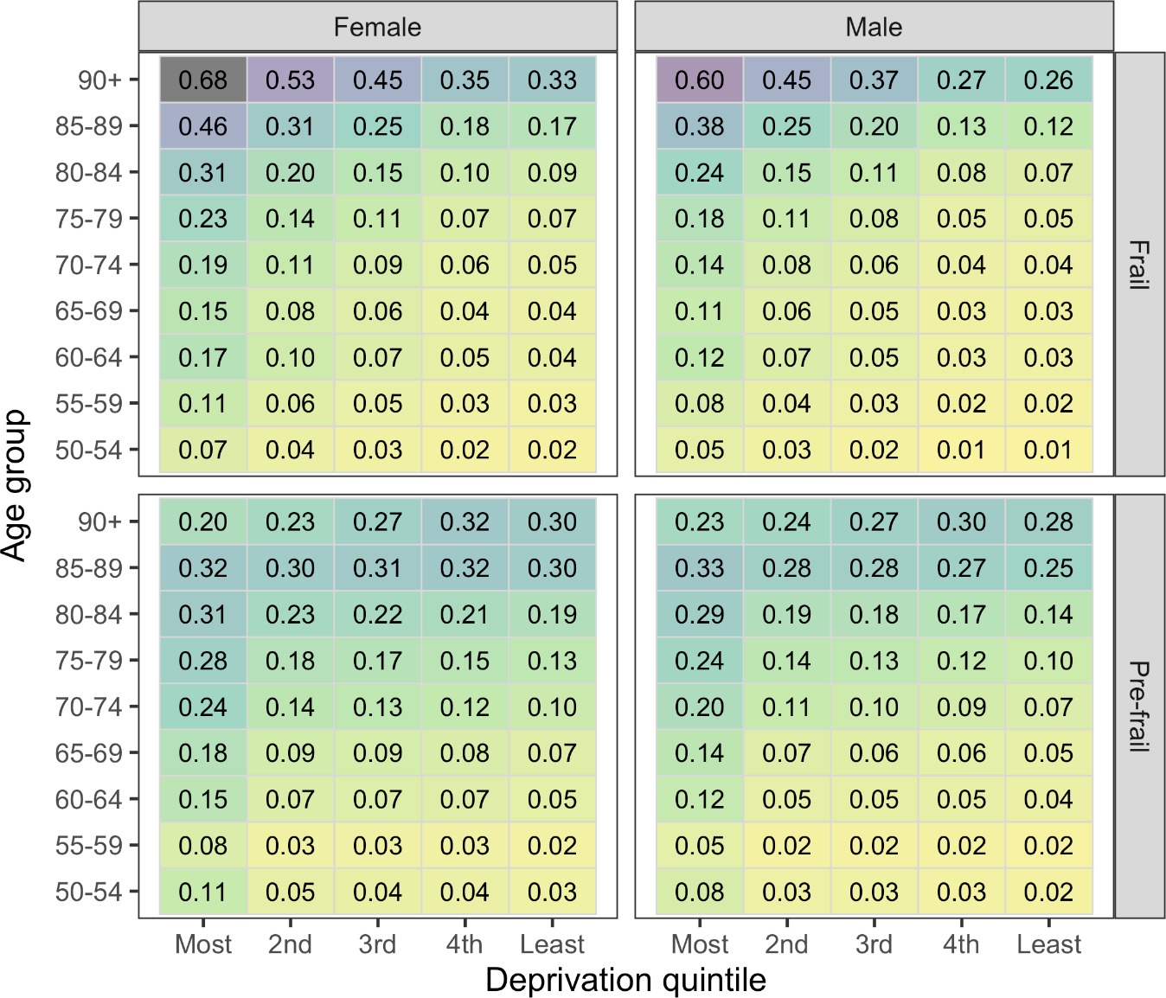

Appendix 6: Comparison of prevalence of frailty and pre-frailty in rural and urban, and in coastal and inland Local Authority Districts among people aged 50 and over. Figures show median prevalence (%), along with 95% confidence intervals.

Frailty status | Frail |  |  | Pre-frail
Sex | Total | Male | Female | Total | Male | Female
Rural (%) | 4.8  (4.3-5.3) | 4.3  (3.9-4.7) | 5.2  (4.7-5.7) | 8.3  (8.0-8.6) | 7.6  (7.3-7.9) | 9.1  (8.8-9.3)
Urban (%) | 7.3  (6.5-8.2) | 6.6  (5.9-7.4) | 7.9  (7.0-8.8) | 8.4  (7.8-9.0) | 7.7  (7.1-8.3) | 9.1  (8.5-9.6)
Inland (%) | 6.7  (6.2-7.1) | 5.9  (5.5-6.3) | 7.3  (6.9-7.8) | 8.2  (8.0-8.3) | 7.4  (7.3-7.6) | 8.8  (8.7-9.0)
Coastal (%) | 8.9  (7.9-9.9) | 7.8  (6.9-8.8) | 9.7  (8.6-10.7) | 9.1  (8.4-9.8) | 8.4  (7.7-9.1) | 9.7  (9.0-10.4)
Rural Inland (%) | 4.5  (4.1-5.0) | 4.0  (3.7-4.4) | 5.0  (4.6-5.5) | 7.9  (7.6-8.2) | 7.1  (6.8-7.4) | 8.6  (8.3-9.0)
Urban Inland (%) | 6.9  (6.4-7.4) | 6.2  (5.7-6.7) | 7.5  (7.0-8.1) | 8.2  (8.0-8.4) | 7.5  (7.3-7.6) | 8.9  (8.7-9.2)
Rural  Coast (%) | 7.4  (6.2-8.6) | 6.7  (5.6-7.8) | 8.0  (6.6-9.4) | 9.1  (8.9-9.3) | 8.4  (8.2-8.7) | 9.7  (9.5-10.0
Urban Coast (%) | 9.0  (7.2-10.8) | 8.1  (6.4-9.8) | 9.7  (7.8-11.7) | 9.1  (7.6-10.7) | 8.4  (6.9-10.0) | 9.6  (8.1-11.2)

Appendix 7a: Estimated prevalence of pre-frailty among people over 50 in each local authority district in England, 2020
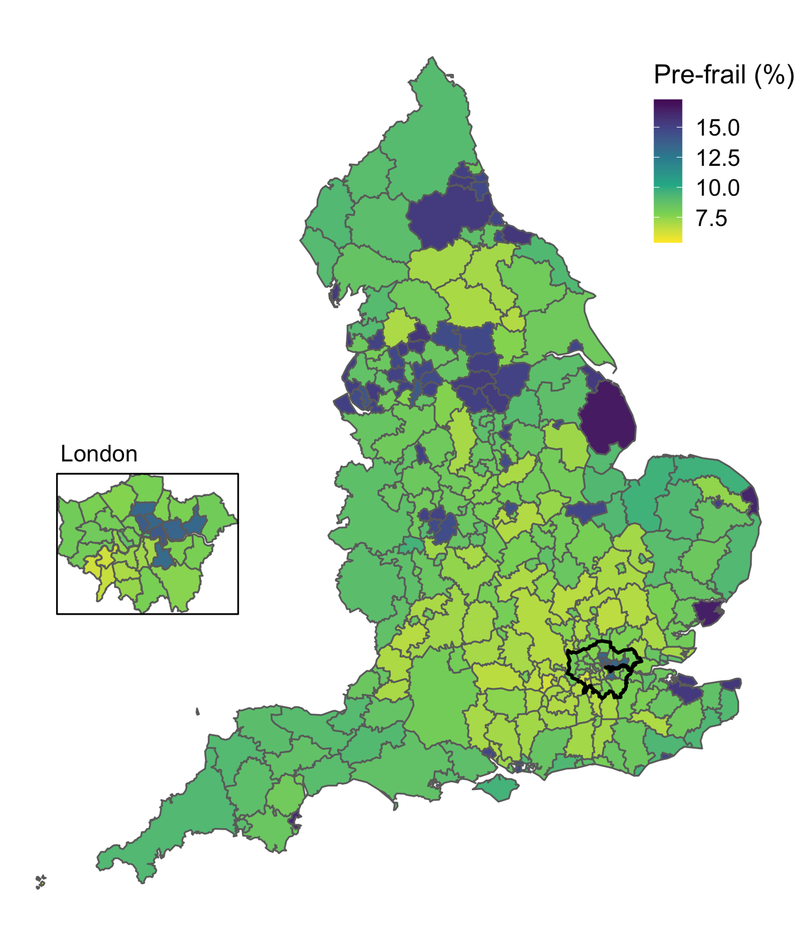

Appendix 7b: Estimated prevalence of pre-frailty among males over 50 in each local authority district in England, 2020
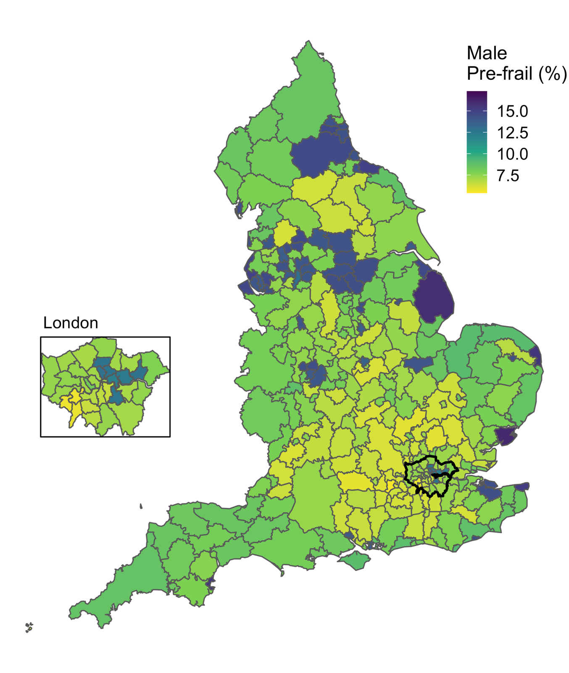

Appendix 7c: Estimated prevalence of pre-frailty among females over 50 in each local authority district in England, 2020
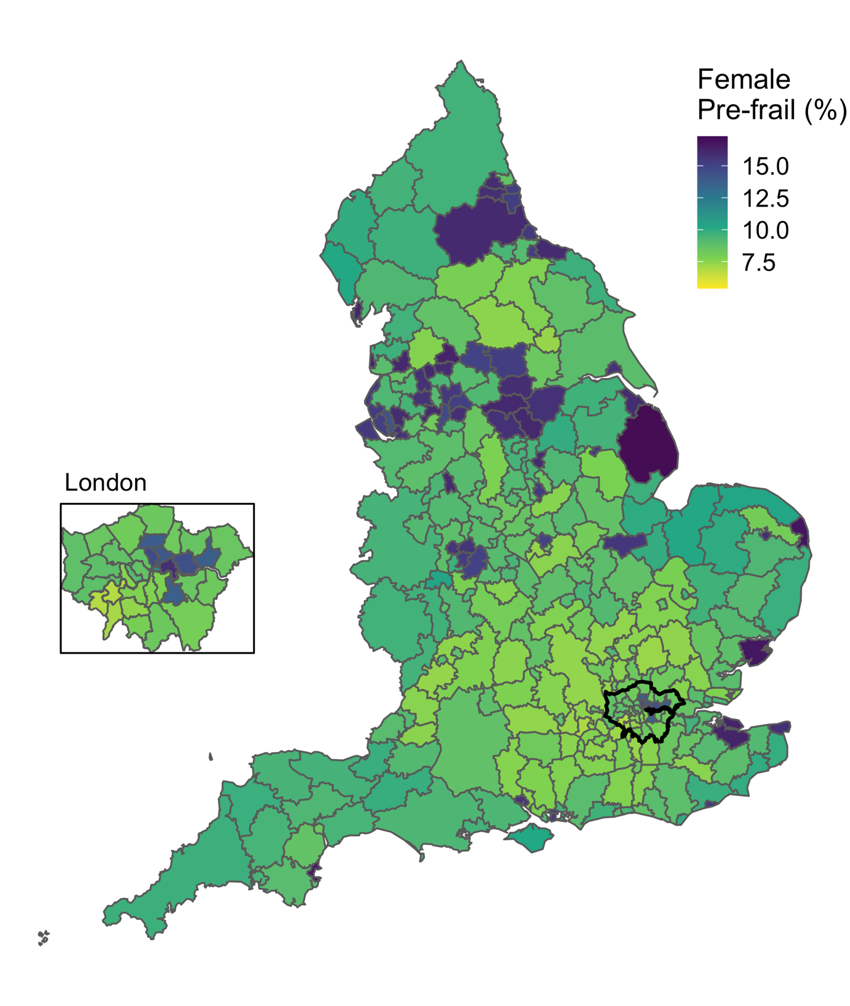

Appendix 7d: Estimated prevalence of frailty among males over 50 in each local authority district in England, 2020
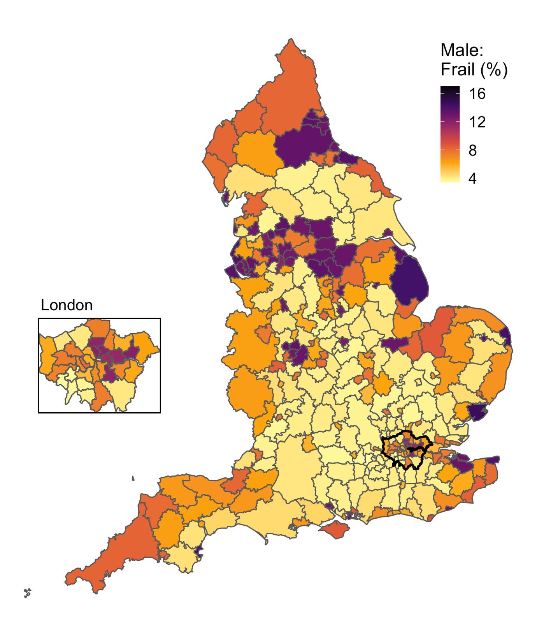

Appendix 7e: Estimated prevalence of frailty among females over 50 in each local authority district in England, 2020
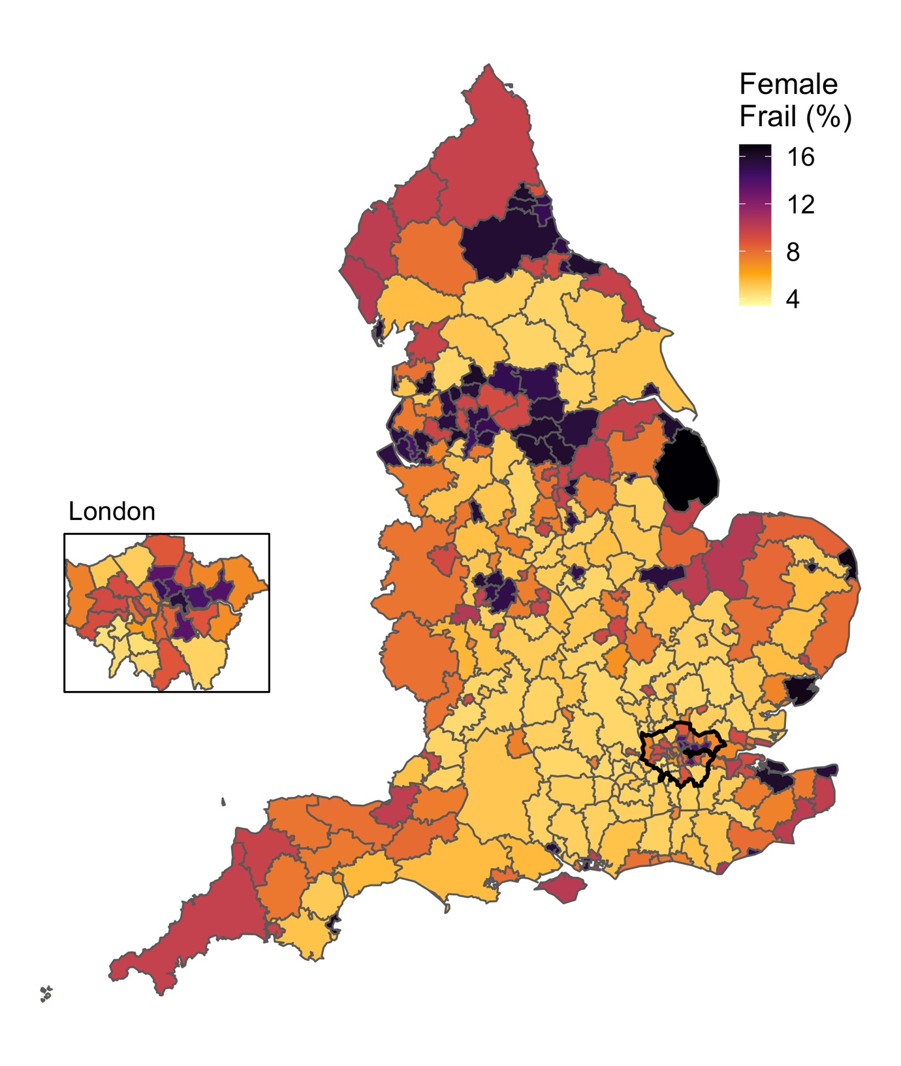

Appendix 8: Prevalence of pre-frailty and frailty in over 50 population of each local authority district in England. Results presented as percent and 95% confidence interval

 | Male and Female,  Over 50 population (%, CI) |  | Male,  Over 50 population (%, CI) |  | Female,  Over 50 population (%, CI)
Local authority district | Pre-frail | Frail | Pre-frail | Frail | Pre-frail | Frail
Adur | 8.8 (8.2-9.5) | 7.2 (6.6-7.8) | 8.2 (7.4-9.1) | 6.5 (5.8-7.3) | 9.4 (8.4-10.3) | 7.8 (6.9-8.6)
Allerdale | 9.2 (8.5-9.9) | 9.1 (8.4-9.9) | 8.4 (7.5-9.4) | 8.2 (7.2-9.1) | 9.9 (8.9-11.0) | 10.0 (8.9-11.2)
Amber Valley | 8.4 (7.8-9.0) | 6.8 (6.2-7.3) | 7.6 (6.8-8.4) | 6.0 (5.3-6.7) | 9.1 (8.2-10.1) | 7.5 (6.6-8.3)
Arun | 9.3 (8.6-9.9) | 7.4 (6.9-8.0) | 8.9 (8.0-9.7) | 6.9 (6.1-7.7) | 9.6 (8.7-10.5) | 7.9 (7.0-8.7)
Ashfield | 8.7 (8.0-9.4) | 8.6 (7.9-9.4) | 7.9 (7.0-8.8) | 7.7 (6.7-8.6) | 9.5 (8.4-10.5) | 9.6 (8.4-10.7)
Ashford | 8.3 (7.6-8.9) | 6.7 (6.1-7.2) | 7.5 (6.7-8.3) | 6.0 (5.3-6.7) | 8.9 (8.0-9.9) | 7.3 (6.5-8.2)
Babergh | 8.5 (8.0-9.1) | 4.9 (4.5-5.3) | 7.9 (7.1-8.6) | 4.4 (3.9-5.0) | 9.2 (8.4-10.0) | 5.4 (4.7-6.0)
Barking and Dagenham | 13.3 (12.0-14.6) | 12.9 (11.7-14.1) | 12.8 (11.1-14.5) | 12.0 (10.4-13.6) | 13.7 (11.8-15.6) | 13.8 (12.0-15.5)
Barnet | 7.6 (7.1-8.2) | 4.5 (4.1-4.9) | 7.1 (6.3-7.8) | 4.1 (3.6-4.6) | 8.1 (7.4-8.9) | 4.9 (4.3-5.5)
Barnsley | 15.2 (14.0-16.4) | 14.5 (13.3-15.6) | 14.3 (12.7-15.9) | 13.0 (11.5-14.5) | 16.1 (14.3-17.9) | 15.8 (14.1-17.5)
Barrow-in-Furness | 15.4 (14.2-16.5) | 14.5 (13.4-15.7) | 14.5 (12.9-16.1) | 13.1 (11.6-14.6) | 16.2 (14.4-17.9) | 15.8 (14.1-17.5)
Basildon | 8.5 (7.8-9.2) | 8.5 (7.8-9.3) | 7.9 (7.0-8.9) | 7.8 (6.8-8.8) | 9.0 (8.0-10.0) | 9.2 (8.1-10.3)
Basingstoke and Deane | 7.5 (7.0-8.1) | 4.4 (4.0-4.8) | 6.7 (6.1-7.4) | 3.9 (3.4-4.3) | 8.3 (7.5-9.0) | 4.9 (4.3-5.5)
Bassetlaw | 9.1 (8.4-9.8) | 9.0 (8.3-9.8) | 8.2 (7.3-9.1) | 8.0 (7.0-8.9) | 9.9 (8.8-11.0) | 10.0 (8.8-11.2)
Bath and North East Somerset | 7.0 (6.5-7.5) | 4.3 (4.0-4.7) | 6.4 (5.7-7.1) | 3.9 (3.4-4.4) | 7.5 (6.8-8.3) | 4.7 (4.2-5.3)
Bedford | 8.4 (7.8-9.0) | 6.9 (6.3-7.5) | 7.6 (6.8-8.4) | 6.1 (5.4-6.9) | 9.1 (8.2-10.1) | 7.6 (6.7-8.5)
Bexley | 7.9 (7.3-8.5) | 6.5 (6.0-7.1) | 7.4 (6.6-8.2) | 6.0 (5.3-6.7) | 8.3 (7.4-9.1) | 6.9 (6.1-7.7)
Birmingham | 14.5 (13.3-15.7) | 14.1 (13.0-15.2) | 14.0 (12.4-15.6) | 13.0 (11.5-14.5) | 15.0 (13.3-16.8) | 15.1 (13.4-16.8)
Blaby | 6.8 (6.3-7.3) | 4.2 (3.8-4.5) | 6.1 (5.5-6.8) | 3.7 (3.2-4.2) | 7.4 (6.6-8.1) | 4.6 (4.0-5.1)
Blackburn with Darwen | 14.8 (13.5-16.0) | 13.8 (12.6-15.0) | 13.7 (12.1-15.4) | 12.3 (10.8-13.9) | 15.7 (13.8-17.6) | 15.2 (13.4-17.0)
Blackpool | 15.3 (14.1-16.5) | 14.6 (13.4-15.8) | 14.3 (12.7-15.9) | 13.1 (11.5-14.6) | 16.2 (14.4-18.0) | 16.0 (14.3-17.8)
Bolsover | 8.7 (8.0-9.5) | 8.6 (7.9-9.4) | 7.9 (7.0-8.9) | 7.7 (6.7-8.6) | 9.5 (8.4-10.5) | 9.5 (8.4-10.7)
Bolton | 15.0 (13.8-16.2) | 14.2 (13.0-15.3) | 14.3 (12.6-15.9) | 12.9 (11.4-14.4) | 15.7 (13.9-17.5) | 15.4 (13.7-17.1)
Boston | 9.1 (8.4-9.8) | 9.0 (8.2-9.7) | 8.5 (7.5-9.4) | 8.1 (7.2-9.1) | 9.7 (8.7-10.7) | 9.8 (8.6-10.9)
Bournemouth, Christchurch and Poole | 9.0 (8.3-9.6) | 7.3 (6.7-7.9) | 8.3 (7.4-9.1) | 6.6 (5.8-7.3) | 9.6 (8.6-10.5) | 8.0 (7.1-8.8)
Bracknell Forest | 6.3 (5.8-6.8) | 4.0 (3.6-4.3) | 5.5 (4.9-6.1) | 3.4 (3.0-3.9) | 7.0 (6.2-7.7) | 4.4 (3.9-5.0)
Bradford | 14.5 (13.4-15.7) | 13.9 (12.8-15.1) | 14.0 (12.4-15.6) | 12.8 (11.3-14.3) | 15.1 (13.3-16.8) | 14.9 (13.2-16.6)
Braintree | 7.9 (7.3-8.4) | 4.5 (4.1-4.9) | 7.1 (6.4-7.8) | 4.0 (3.6-4.5) | 8.5 (7.7-9.3) | 5.0 (4.4-5.6)
Breckland | 9.2 (8.6-9.9) | 7.4 (6.8-8.0) | 8.4 (7.5-9.2) | 6.6 (5.8-7.3) | 10.0 (9.0-11.0) | 8.1 (7.3-9.0)
Brent | 8.0 (7.3-8.7) | 8.3 (7.5-9.1) | 7.3 (6.4-8.3) | 7.4 (6.4-8.4) | 8.7 (7.6-9.7) | 9.1 (7.9-10.3)
Brentwood | 7.1 (6.6-7.6) | 4.4 (4.0-4.7) | 6.5 (5.8-7.2) | 3.9 (3.4-4.4) | 7.6 (6.9-8.4) | 4.8 (4.2-5.3)
Brighton and Hove | 8.0 (7.3-8.6) | 6.6 (6.0-7.2) | 7.2 (6.3-8.0) | 5.8 (5.1-6.6) | 8.7 (7.7-9.7) | 7.3 (6.4-8.2)
Bristol, City of | 8.5 (7.8-9.2) | 8.6 (7.9-9.4) | 7.9 (6.9-8.8) | 7.8 (6.8-8.8) | 9.1 (8.1-10.2) | 9.4 (8.3-10.6)
Broadland | 7.4 (6.9-8.0) | 4.5 (4.1-4.9) | 6.7 (6.0-7.4) | 4.0 (3.5-4.5) | 8.0 (7.3-8.8) | 5.0 (4.4-5.5)
Bromley | 7.6 (7.0-8.1) | 4.4 (4.1-4.8) | 7.1 (6.4-7.8) | 4.1 (3.6-4.6) | 8.0 (7.2-8.7) | 4.8 (4.2-5.3)
Bromsgrove | 7.2 (6.7-7.7) | 4.4 (4.0-4.8) | 6.5 (5.8-7.2) | 3.9 (3.4-4.4) | 7.9 (7.1-8.6) | 4.9 (4.3-5.5)
Broxbourne | 8.3 (7.7-8.9) | 6.7 (6.2-7.3) | 7.8 (7.0-8.6) | 6.2 (5.5-6.9) | 8.7 (7.8-9.6) | 7.2 (6.4-8.0)
Broxtowe | 8.2 (7.6-8.7) | 4.7 (4.3-5.1) | 7.4 (6.7-8.1) | 4.2 (3.7-4.7) | 8.9 (8.1-9.7) | 5.2 (4.6-5.8)
Buckinghamshire | 6.8 (6.3-7.3) | 4.2 (3.8-4.6) | 6.1 (5.5-6.8) | 3.8 (3.3-4.2) | 7.4 (6.6-8.1) | 4.6 (4.1-5.2)
Burnley | 15.2 (14.0-16.4) | 14.3 (13.2-15.5) | 14.5 (12.9-16.1) | 13.0 (11.5-14.5) | 15.9 (14.2-17.7) | 15.5 (13.8-17.2)
Bury | 8.6 (7.9-9.3) | 8.5 (7.8-9.3) | 7.9 (7.0-8.9) | 7.7 (6.8-8.7) | 9.1 (8.1-10.1) | 9.3 (8.1-10.4)
Calderdale | 8.4 (7.7-9.1) | 8.4 (7.6-9.1) | 7.7 (6.7-8.6) | 7.5 (6.5-8.4) | 9.1 (8.0-10.1) | 9.2 (8.0-10.3)
Cambridge | 7.9 (7.4-8.5) | 4.7 (4.3-5.1) | 7.1 (6.4-7.8) | 4.2 (3.6-4.7) | 8.7 (7.9-9.5) | 5.3 (4.6-5.9)
Camden | 7.9 (7.3-8.6) | 6.6 (6.1-7.2) | 7.2 (6.3-8.0) | 5.9 (5.2-6.6) | 8.7 (7.7-9.6) | 7.4 (6.5-8.2)
Cannock Chase | 8.2 (7.6-8.8) | 6.7 (6.1-7.2) | 7.4 (6.6-8.2) | 5.9 (5.2-6.6) | 8.9 (8.0-9.9) | 7.3 (6.5-8.2)
Canterbury | 8.7 (8.1-9.4) | 7.1 (6.6-7.7) | 8.2 (7.4-9.1) | 6.6 (5.8-7.3) | 9.2 (8.3-10.1) | 7.6 (6.8-8.5)
Carlisle | 9.0 (8.3-9.7) | 9.0 (8.2-9.7) | 8.3 (7.4-9.2) | 8.1 (7.2-9.1) | 9.6 (8.6-10.6) | 9.8 (8.6-10.9)
Castle Point | 9.0 (8.3-9.6) | 7.2 (6.6-7.8) | 8.3 (7.5-9.2) | 6.5 (5.8-7.3) | 9.6 (8.6-10.5) | 7.8 (7.0-8.7)
Central Bedfordshire | 6.7 (6.2-7.2) | 4.2 (3.8-4.6) | 6.0 (5.3-6.6) | 3.7 (3.2-4.1) | 7.4 (6.7-8.2) | 4.7 (4.1-5.3)
Charnwood | 8.0 (7.5-8.5) | 4.6 (4.2-5.0) | 7.2 (6.5-7.9) | 4.1 (3.6-4.6) | 8.7 (8.0-9.5) | 5.1 (4.5-5.8)
Chelmsford | 7.0 (6.5-7.5) | 4.3 (3.9-4.7) | 6.3 (5.7-7.0) | 3.8 (3.4-4.3) | 7.6 (6.8-8.3) | 4.7 (4.1-5.3)
Cheltenham | 8.1 (7.6-8.7) | 4.8 (4.4-5.2) | 7.5 (6.8-8.2) | 4.3 (3.8-4.8) | 8.7 (8.0-9.5) | 5.2 (4.6-5.8)
Cherwell | 8.0 (7.4-8.5) | 4.6 (4.2-5.0) | 7.1 (6.4-7.8) | 4.1 (3.6-4.6) | 8.7 (7.9-9.5) | 5.1 (4.5-5.8)
Cheshire East | 8.2 (7.6-8.7) | 4.7 (4.3-5.1) | 7.4 (6.7-8.2) | 4.2 (3.7-4.7) | 8.8 (8.0-9.6) | 5.2 (4.6-5.8)
Cheshire West and Chester | 8.5 (7.9-9.1) | 6.9 (6.3-7.4) | 7.8 (7.0-8.7) | 6.2 (5.5-6.9) | 9.1 (8.2-10.1) | 7.5 (6.6-8.3)
Chesterfield | 8.7 (8.0-9.4) | 8.7 (7.9-9.4) | 8.0 (7.1-8.9) | 7.8 (6.8-8.7) | 9.4 (8.3-10.4) | 9.5 (8.3-10.6)
Chichester | 8.5 (8.0-9.0) | 4.9 (4.5-5.3) | 8.0 (7.2-8.7) | 4.5 (3.9-5.0) | 9.0 (8.2-9.7) | 5.2 (4.6-5.8)
Chorley | 8.4 (7.7-9.0) | 6.7 (6.2-7.3) | 7.5 (6.6-8.3) | 5.9 (5.2-6.6) | 9.2 (8.3-10.2) | 7.5 (6.6-8.4)
City of London | 9.2 (8.6-9.9) | 5.5 (5.0-6.0) | 7.3 (6.5-8.0) | 4.3 (3.7-4.8) | 11.6 (10.4-12.7) | 7.0 (6.2-7.9)
Colchester | 8.3 (7.7-8.9) | 6.7 (6.1-7.2) | 7.7 (6.8-8.5) | 6.1 (5.3-6.8) | 8.8 (7.9-9.7) | 7.2 (6.4-8.1)
Copeland | 9.1 (8.4-9.8) | 9.0 (8.3-9.8) | 8.1 (7.2-9.0) | 7.8 (6.9-8.8) | 10.1 (9.0-11.2) | 10.2 (9.0-11.5)
Corby | 7.8 (7.1-8.5) | 7.9 (7.1-8.6) | 7.1 (6.2-8.1) | 7.1 (6.1-8.0) | 8.4 (7.3-9.4) | 8.6 (7.4-9.8)
Cornwall | 9.2 (8.5-9.9) | 9.1 (8.3-9.8) | 8.6 (7.7-9.6) | 8.3 (7.3-9.3) | 9.7 (8.7-10.7) | 9.8 (8.7-10.9)
Cotswold | 7.2 (6.6-7.7) | 4.4 (4.0-4.8) | 6.5 (5.9-7.2) | 3.9 (3.4-4.4) | 7.7 (7.0-8.5) | 4.8 (4.2-5.3)
County Durham | 15.3 (14.2-16.5) | 14.5 (13.4-15.7) | 14.6 (13.0-16.2) | 13.2 (11.7-14.7) | 16.0 (14.3-17.7) | 15.8 (14.1-17.4)
Coventry | 8.7 (8.0-9.4) | 8.8 (8.0-9.5) | 8.0 (7.1-8.9) | 7.9 (6.9-8.9) | 9.3 (8.3-10.4) | 9.6 (8.4-10.7)
Craven | 8.1 (7.6-8.7) | 4.7 (4.3-5.1) | 7.6 (6.8-8.3) | 4.3 (3.8-4.8) | 8.7 (7.9-9.4) | 5.1 (4.5-5.7)
Crawley | 7.7 (7.1-8.3) | 6.5 (5.9-7.0) | 6.9 (6.1-7.7) | 5.7 (5.0-6.4) | 8.4 (7.4-9.4) | 7.2 (6.3-8.0)
Croydon | 7.9 (7.2-8.6) | 8.1 (7.4-8.9) | 7.4 (6.4-8.3) | 7.4 (6.5-8.4) | 8.3 (7.3-9.4) | 8.7 (7.6-9.9)
Dacorum | 7.6 (7.1-8.2) | 4.5 (4.1-4.9) | 7.0 (6.3-7.7) | 4.1 (3.6-4.6) | 8.2 (7.5-9.0) | 5.0 (4.4-5.6)
Darlington | 8.8 (8.1-9.5) | 8.8 (8.0-9.5) | 8.2 (7.3-9.1) | 7.9 (7.0-8.9) | 9.4 (8.4-10.4) | 9.5 (8.4-10.6)
Dartford | 8.0 (7.4-8.6) | 6.6 (6.1-7.2) | 7.2 (6.4-8.0) | 5.9 (5.2-6.6) | 8.7 (7.7-9.7) | 7.3 (6.5-8.2)
Daventry | 7.9 (7.4-8.4) | 4.5 (4.1-4.9) | 6.9 (6.2-7.6) | 3.9 (3.4-4.4) | 8.8 (8.0-9.7) | 5.1 (4.5-5.7)
Derby | 8.7 (8.0-9.4) | 8.8 (8.0-9.5) | 8.1 (7.1-9.0) | 8.0 (7.0-9.0) | 9.2 (8.2-10.2) | 9.5 (8.3-10.6)
Derbyshire Dales | 7.1 (6.6-7.6) | 4.3 (3.9-4.7) | 6.3 (5.7-7.0) | 3.8 (3.3-4.3) | 7.8 (7.0-8.5) | 4.8 (4.2-5.4)
Doncaster | 15.0 (13.9-16.2) | 14.3 (13.2-15.5) | 14.3 (12.7-15.9) | 13.0 (11.5-14.6) | 15.7 (14.0-17.4) | 15.5 (13.8-17.2)
Dorset | 8.7 (8.2-9.3) | 5.0 (4.6-5.4) | 8.0 (7.3-8.8) | 4.5 (4.0-5.0) | 9.3 (8.5-10.1) | 5.4 (4.8-6.0)
Dover | 9.1 (8.4-9.8) | 9.0 (8.3-9.8) | 8.3 (7.4-9.3) | 8.0 (7.1-9.0) | 9.9 (8.8-10.9) | 9.9 (8.8-11.1)
Dudley | 9.0 (8.3-9.7) | 8.9 (8.1-9.6) | 8.3 (7.3-9.2) | 8.0 (7.0-8.9) | 9.7 (8.6-10.7) | 9.7 (8.6-10.9)
Ealing | 8.2 (7.4-8.9) | 8.4 (7.6-9.2) | 7.4 (6.5-8.4) | 7.5 (6.5-8.5) | 8.8 (7.7-9.9) | 9.3 (8.1-10.5)
East Cambridgeshire | 7.1 (6.6-7.6) | 4.3 (4.0-4.7) | 6.3 (5.7-7.0) | 3.8 (3.3-4.3) | 7.9 (7.1-8.6) | 4.9 (4.3-5.4)
East Devon | 9.0 (8.4-9.5) | 5.1 (4.7-5.5) | 8.4 (7.6-9.2) | 4.7 (4.1-5.2) | 9.5 (8.7-10.3) | 5.5 (4.9-6.1)
East Hampshire | 7.1 (6.6-7.6) | 4.4 (4.0-4.8) | 6.5 (5.8-7.2) | 4.0 (3.5-4.5) | 7.7 (6.9-8.4) | 4.8 (4.3-5.4)
East Hertfordshire | 6.6 (6.1-7.1) | 4.2 (3.8-4.5) | 6.0 (5.3-6.6) | 3.7 (3.2-4.2) | 7.3 (6.5-8.0) | 4.6 (4.0-5.2)
East Lindsey | 16.6 (15.5-17.8) | 15.7 (14.6-16.8) | 15.9 (14.3-17.5) | 14.3 (12.7-15.8) | 17.3 (15.6-18.9) | 17.0 (15.3-18.6)
East Northamptonshire | 8.0 (7.5-8.6) | 4.6 (4.2-5.0) | 7.1 (6.4-7.8) | 4.0 (3.5-4.5) | 8.9 (8.1-9.7) | 5.2 (4.6-5.8)
East Riding of Yorkshire | 8.2 (7.7-8.8) | 4.7 (4.3-5.1) | 7.5 (6.8-8.2) | 4.2 (3.7-4.7) | 8.9 (8.1-9.7) | 5.1 (4.5-5.7)
East Staffordshire | 8.2 (7.6-8.8) | 6.6 (6.1-7.2) | 7.4 (6.6-8.2) | 5.9 (5.2-6.6) | 9.0 (8.0-9.9) | 7.4 (6.5-8.2)
East Suffolk | 9.2 (8.6-9.8) | 7.4 (6.8-8.0) | 8.6 (7.7-9.4) | 6.7 (6.0-7.5) | 9.8 (8.8-10.7) | 8.0 (7.2-8.9)
Eastbourne | 9.6 (8.9-10.3) | 9.8 (9.0-10.5) | 9.2 (8.2-10.1) | 9.1 (8.0-10.1) | 10.0 (8.9-11.0) | 10.4 (9.3-11.5)
Eastleigh | 6.9 (6.4-7.4) | 4.3 (3.9-4.7) | 6.3 (5.6-6.9) | 3.8 (3.3-4.3) | 7.5 (6.8-8.3) | 4.7 (4.1-5.3)
Eden | 8.9 (8.3-9.5) | 7.1 (6.5-7.7) | 8.1 (7.2-8.9) | 6.3 (5.6-7.0) | 9.7 (8.7-10.6) | 7.9 (7.0-8.7)
Elmbridge | 6.8 (6.3-7.3) | 4.3 (3.9-4.7) | 6.3 (5.6-7.0) | 3.9 (3.4-4.4) | 7.2 (6.5-8.0) | 4.6 (4.0-5.2)
Enfield | 7.9 (7.2-8.6) | 8.1 (7.3-8.8) | 7.4 (6.5-8.4) | 7.4 (6.4-8.4) | 8.3 (7.3-9.4) | 8.7 (7.5-9.8)
Epping Forest | 7.8 (7.3-8.3) | 4.5 (4.1-4.9) | 7.3 (6.5-8.0) | 4.2 (3.6-4.7) | 8.2 (7.5-9.0) | 4.9 (4.3-5.5)
Epsom and Ewell | 6.8 (6.3-7.3) | 4.3 (3.9-4.7) | 6.2 (5.5-6.9) | 3.8 (3.3-4.3) | 7.4 (6.7-8.2) | 4.7 (4.1-5.3)
Erewash | 8.3 (7.7-9.0) | 6.8 (6.2-7.4) | 7.6 (6.8-8.5) | 6.1 (5.4-6.8) | 9.0 (8.1-9.9) | 7.4 (6.6-8.3)
Exeter | 8.1 (7.5-8.7) | 6.5 (6.0-7.1) | 7.7 (6.9-8.5) | 6.1 (5.4-6.8) | 8.4 (7.5-9.2) | 6.9 (6.1-7.7)
Fareham | 7.2 (6.7-7.8) | 4.4 (4.1-4.8) | 6.6 (5.9-7.3) | 4.0 (3.5-4.5) | 7.8 (7.1-8.6) | 4.8 (4.3-5.4)
Fenland | 9.2 (8.5-9.9) | 9.2 (8.4-9.9) | 8.4 (7.5-9.4) | 8.2 (7.2-9.2) | 9.9 (8.9-10.9) | 10.0 (8.9-11.2)
Folkestone and Hythe | 9.3 (8.6-10.0) | 9.2 (8.5-10.0) | 8.6 (7.6-9.5) | 8.3 (7.3-9.3) | 9.9 (8.9-11.0) | 10.1 (8.9-11.2)
Forest of Dean | 8.7 (8.1-9.4) | 7.0 (6.4-7.6) | 7.9 (7.0-8.7) | 6.2 (5.4-6.9) | 9.6 (8.6-10.5) | 7.8 (6.9-8.7)
Fylde | 8.3 (7.8-8.9) | 4.7 (4.3-5.1) | 7.6 (6.9-8.3) | 4.2 (3.7-4.7) | 9.0 (8.2-9.7) | 5.1 (4.5-5.8)
Gateshead | 15.2 (14.1-16.4) | 14.6 (13.5-15.8) | 14.6 (13.1-16.2) | 13.4 (11.9-14.9) | 15.8 (14.1-17.5) | 15.7 (14.1-17.4)
Gedling | 7.8 (7.3-8.4) | 4.5 (4.1-4.8) | 7.2 (6.4-7.9) | 4.0 (3.5-4.5) | 8.5 (7.7-9.2) | 4.9 (4.3-5.5)
Gloucester | 8.4 (7.7-9.1) | 8.5 (7.8-9.3) | 7.8 (6.8-8.7) | 7.7 (6.8-8.7) | 9.0 (8.0-10.0) | 9.3 (8.1-10.4)
Gosport | 8.5 (7.9-9.1) | 6.9 (6.4-7.5) | 7.8 (6.9-8.6) | 6.2 (5.5-6.9) | 9.2 (8.3-10.1) | 7.6 (6.8-8.5)
Gravesham | 8.8 (8.1-9.6) | 8.9 (8.1-9.7) | 8.0 (7.1-8.9) | 7.9 (6.9-8.8) | 9.6 (8.5-10.7) | 9.9 (8.7-11.1)
Great Yarmouth | 16.2 (15.0-17.3) | 15.5 (14.3-16.6) | 15.5 (14.0-17.1) | 14.1 (12.6-15.7) | 16.8 (15.1-18.4) | 16.7 (15.0-18.3)
Greenwich | 7.7 (7.0-8.5) | 8.0 (7.2-8.8) | 7.0 (6.1-8.0) | 7.1 (6.1-8.1) | 8.4 (7.3-9.5) | 8.8 (7.6-10.0)
Guildford | 6.9 (6.3-7.4) | 4.3 (3.9-4.7) | 6.2 (5.5-6.9) | 3.8 (3.3-4.3) | 7.5 (6.7-8.2) | 4.7 (4.1-5.3)
Hackney | 13.4 (12.0-14.7) | 12.9 (11.7-14.2) | 12.7 (10.9-14.4) | 11.8 (10.2-13.4) | 14.0 (12.0-15.9) | 14.0 (12.1-15.8)
Halton | 15.0 (13.8-16.2) | 14.1 (13.0-15.3) | 14.2 (12.7-15.8) | 12.9 (11.3-14.4) | 15.7 (13.9-17.4) | 15.3 (13.6-17.0)
Hambleton | 7.1 (6.6-7.6) | 4.3 (3.9-4.7) | 6.5 (5.8-7.1) | 3.8 (3.4-4.3) | 7.7 (6.9-8.4) | 4.7 (4.1-5.3)
Hammersmith and Fulham | 7.4 (6.7-8.1) | 7.5 (6.8-8.3) | 7.1 (6.2-8.1) | 7.1 (6.2-8.1) | 7.6 (6.6-8.6) | 7.9 (6.8-9.0)
Harborough | 6.9 (6.4-7.4) | 4.2 (3.8-4.6) | 6.1 (5.5-6.8) | 3.7 (3.2-4.2) | 7.6 (6.8-8.3) | 4.7 (4.1-5.2)
Haringey | 13.3 (12.0-14.6) | 12.7 (11.5-13.9) | 12.8 (11.0-14.5) | 11.7 (10.1-13.3) | 13.8 (11.9-15.7) | 13.6 (11.8-15.3)
Harlow | 8.1 (7.4-8.7) | 8.2 (7.5-8.9) | 7.7 (6.8-8.6) | 7.6 (6.7-8.6) | 8.4 (7.4-9.3) | 8.7 (7.6-9.8)
Harrogate | 7.0 (6.5-7.5) | 4.3 (3.9-4.7) | 6.4 (5.7-7.1) | 3.9 (3.4-4.4) | 7.5 (6.8-8.3) | 4.7 (4.1-5.3)
Harrow | 7.8 (7.3-8.3) | 4.6 (4.2-5.0) | 7.2 (6.5-7.9) | 4.2 (3.7-4.7) | 8.4 (7.6-9.2) | 5.1 (4.4-5.7)
Hart | 7.0 (6.4-7.5) | 4.3 (3.9-4.7) | 6.3 (5.6-7.0) | 3.9 (3.4-4.4) | 7.5 (6.8-8.3) | 4.7 (4.2-5.3)
Hartlepool | 14.8 (13.7-16.0) | 14.1 (13.0-15.3) | 14.2 (12.7-15.8) | 12.9 (11.4-14.5) | 15.4 (13.7-17.1) | 15.2 (13.5-16.8)
Hastings | 14.9 (13.7-16.0) | 14.2 (13.0-15.3) | 14.4 (12.8-16.0) | 13.1 (11.6-14.6) | 15.3 (13.6-17.0) | 15.1 (13.5-16.8)
Havant | 9.2 (8.5-9.9) | 9.2 (8.5-10.0) | 8.7 (7.8-9.7) | 8.6 (7.6-9.5) | 9.6 (8.6-10.6) | 9.8 (8.7-10.9)
Havering | 8.1 (7.5-8.7) | 6.7 (6.1-7.2) | 7.7 (6.9-8.5) | 6.2 (5.5-6.9) | 8.4 (7.6-9.3) | 7.0 (6.2-7.8)
Herefordshire, County of | 8.9 (8.3-9.5) | 7.2 (6.6-7.8) | 8.2 (7.3-9.0) | 6.4 (5.7-7.2) | 9.6 (8.7-10.5) | 7.9 (7.0-8.7)
Hertsmere | 7.8 (7.3-8.3) | 4.6 (4.2-5.0) | 7.4 (6.6-8.1) | 4.2 (3.7-4.7) | 8.2 (7.5-8.9) | 4.9 (4.3-5.5)
High Peak | 7.7 (7.1-8.2) | 4.5 (4.1-4.8) | 6.8 (6.1-7.5) | 3.9 (3.4-4.4) | 8.5 (7.7-9.3) | 5.0 (4.4-5.6)
Hillingdon | 8.1 (7.5-8.7) | 6.7 (6.1-7.3) | 7.4 (6.6-8.2) | 6.0 (5.3-6.7) | 8.8 (7.8-9.7) | 7.4 (6.5-8.2)
Hinckley and Bosworth | 7.9 (7.4-8.4) | 4.5 (4.1-4.9) | 7.1 (6.4-7.8) | 4.0 (3.5-4.4) | 8.7 (7.9-9.5) | 5.0 (4.4-5.6)
Horsham | 7.1 (6.6-7.6) | 4.4 (4.0-4.8) | 6.5 (5.8-7.2) | 3.9 (3.4-4.4) | 7.7 (6.9-8.4) | 4.8 (4.2-5.4)
Hounslow | 8.0 (7.3-8.8) | 8.2 (7.4-9.0) | 7.3 (6.3-8.2) | 7.3 (6.3-8.2) | 8.8 (7.7-9.9) | 9.1 (7.9-10.3)
Huntingdonshire | 7.9 (7.4-8.5) | 4.6 (4.2-5.0) | 7.1 (6.4-7.8) | 4.0 (3.5-4.5) | 8.7 (7.9-9.5) | 5.1 (4.5-5.7)
Hyndburn | 15.3 (14.0-16.5) | 14.4 (13.3-15.6) | 14.4 (12.8-16.1) | 13.0 (11.5-14.6) | 16.0 (14.2-17.8) | 15.7 (14.0-17.4)
Ipswich | 8.8 (8.1-9.5) | 8.9 (8.1-9.6) | 8.0 (7.1-8.9) | 7.9 (6.9-8.8) | 9.5 (8.4-10.6) | 9.8 (8.6-10.9)
Isle of Wight | 9.6 (8.9-10.3) | 9.5 (8.7-10.2) | 8.9 (8.0-9.9) | 8.6 (7.6-9.6) | 10.2 (9.1-11.2) | 10.2 (9.1-11.4)
Isles of Scilly | 7.1 (6.5-7.6) | 4.6 (4.1-5.0) | 6.1 (5.5-6.8) | 3.9 (3.4-4.4) | 8.0 (7.2-8.8) | 5.2 (4.6-5.9)
Islington | 13.8 (12.5-15.1) | 13.3 (12.0-14.5) | 12.9 (11.1-14.6) | 11.9 (10.3-13.5) | 14.6 (12.6-16.6) | 14.5 (12.7-16.4)
Kensington and Chelsea | 8.6 (7.9-9.3) | 8.9 (8.1-9.6) | 8.1 (7.1-9.0) | 8.1 (7.1-9.1) | 9.1 (8.1-10.1) | 9.6 (8.4-10.7)
Kettering | 8.2 (7.6-8.9) | 6.7 (6.1-7.2) | 7.5 (6.7-8.3) | 6.0 (5.3-6.7) | 8.9 (8.0-9.8) | 7.3 (6.5-8.2)
King's Lynn and West Norfolk | 9.6 (8.9-10.3) | 9.5 (8.7-10.3) | 9.0 (8.0-10.0) | 8.6 (7.6-9.6) | 10.2 (9.2-11.2) | 10.3 (9.2-11.4)
Kingston upon Hull, City of | 14.8 (13.6-16.0) | 14.0 (12.9-15.2) | 13.9 (12.3-15.5) | 12.6 (11.1-14.1) | 15.7 (13.8-17.5) | 15.4 (13.6-17.1)
Kingston upon Thames | 6.5 (6.0-7.0) | 4.1 (3.7-4.5) | 5.8 (5.2-6.5) | 3.6 (3.2-4.1) | 7.1 (6.3-7.8) | 4.5 (3.9-5.1)
Kirklees | 8.5 (7.8-9.2) | 8.5 (7.7-9.2) | 7.8 (6.8-8.7) | 7.6 (6.6-8.5) | 9.2 (8.2-10.3) | 9.3 (8.2-10.5)
Knowsley | 14.1 (13.0-15.3) | 13.5 (12.4-14.6) | 13.9 (12.3-15.5) | 12.7 (11.2-14.2) | 14.3 (12.7-15.9) | 14.2 (12.6-15.7)
Lambeth | 7.2 (6.4-7.9) | 7.6 (6.8-8.4) | 6.6 (5.7-7.6) | 6.8 (5.8-7.9) | 7.7 (6.6-8.8) | 8.2 (7.0-9.4)
Lancaster | 9.0 (8.3-9.7) | 8.9 (8.2-9.7) | 8.4 (7.5-9.4) | 8.1 (7.1-9.1) | 9.6 (8.6-10.6) | 9.6 (8.5-10.8)
Leeds | 14.7 (13.6-15.9) | 14.1 (12.9-15.2) | 14.3 (12.7-15.9) | 13.0 (11.5-14.5) | 15.2 (13.5-16.9) | 15.0 (13.4-16.7)
Leicester | 14.3 (13.1-15.5) | 13.8 (12.6-15.0) | 13.6 (12.0-15.2) | 12.6 (11.0-14.1) | 15.0 (13.2-16.8) | 14.9 (13.2-16.7)
Lewes | 8.4 (7.9-9.0) | 4.9 (4.5-5.3) | 7.8 (7.1-8.6) | 4.5 (3.9-5.0) | 9.0 (8.2-9.8) | 5.3 (4.7-5.9)
Lewisham | 13.2 (11.8-14.5) | 12.7 (11.5-14.0) | 12.6 (10.9-14.4) | 11.8 (10.2-13.4) | 13.6 (11.7-15.6) | 13.6 (11.8-15.4)
Lichfield | 8.3 (7.7-8.8) | 4.7 (4.3-5.1) | 7.4 (6.7-8.2) | 4.2 (3.7-4.7) | 9.0 (8.2-9.8) | 5.2 (4.6-5.8)
Lincoln | 14.8 (13.6-16.0) | 14.1 (13.0-15.2) | 14.3 (12.7-15.8) | 13.0 (11.5-14.5) | 15.3 (13.6-17.0) | 15.1 (13.4-16.7)
Liverpool | 14.6 (13.4-15.8) | 14.0 (12.9-15.1) | 14.1 (12.5-15.6) | 12.9 (11.4-14.4) | 15.1 (13.4-16.8) | 15.0 (13.3-16.6)
Luton | 8.4 (7.7-9.1) | 8.6 (7.9-9.4) | 7.7 (6.7-8.6) | 7.7 (6.7-8.7) | 9.1 (8.1-10.2) | 9.5 (8.3-10.7)
Maidstone | 8.4 (7.8-9.1) | 6.8 (6.2-7.4) | 7.7 (6.9-8.5) | 6.1 (5.4-6.8) | 9.1 (8.2-10.1) | 7.5 (6.6-8.3)
Maldon | 8.1 (7.6-8.6) | 4.6 (4.2-5.0) | 7.2 (6.5-7.9) | 4.0 (3.5-4.5) | 9.0 (8.2-9.8) | 5.1 (4.5-5.8)
Malvern Hills | 8.8 (8.3-9.4) | 5.0 (4.6-5.5) | 7.9 (7.2-8.7) | 4.4 (3.9-5.0) | 9.6 (8.8-10.5) | 5.6 (5.0-6.2)
Manchester | 13.9 (12.6-15.2) | 13.2 (12.0-14.4) | 13.0 (11.4-14.7) | 11.9 (10.3-13.5) | 14.6 (12.7-16.6) | 14.4 (12.6-16.2)
Mansfield | 15.2 (14.0-16.4) | 14.4 (13.3-15.6) | 14.4 (12.8-15.9) | 13.1 (11.5-14.6) | 15.9 (14.1-17.7) | 15.7 (14.0-17.4)
Medway | 8.3 (7.6-9.0) | 8.4 (7.6-9.1) | 7.6 (6.7-8.5) | 7.5 (6.5-8.4) | 9.0 (8.0-10.1) | 9.2 (8.0-10.4)
Melton | 8.1 (7.6-8.7) | 4.7 (4.3-5.1) | 7.2 (6.5-7.9) | 4.1 (3.6-4.6) | 9.1 (8.2-9.9) | 5.3 (4.7-5.9)
Mendip | 8.6 (8.0-9.2) | 6.9 (6.4-7.5) | 7.9 (7.1-8.8) | 6.2 (5.5-7.0) | 9.2 (8.3-10.1) | 7.5 (6.7-8.3)
Merton | 7.0 (6.5-7.5) | 4.1 (3.7-4.5) | 6.4 (5.8-7.1) | 3.7 (3.2-4.2) | 7.4 (6.7-8.2) | 4.4 (3.8-5.0)
Mid Devon | 8.7 (8.1-9.3) | 7.0 (6.4-7.5) | 8.0 (7.2-8.8) | 6.3 (5.5-7.0) | 9.3 (8.4-10.2) | 7.6 (6.7-8.4)
Mid Suffolk | 8.3 (7.8-8.9) | 4.7 (4.3-5.1) | 7.5 (6.8-8.2) | 4.2 (3.7-4.7) | 9.1 (8.3-9.9) | 5.3 (4.6-5.9)
Mid Sussex | 7.1 (6.6-7.6) | 4.4 (4.0-4.8) | 6.4 (5.7-7.1) | 3.9 (3.4-4.5) | 7.7 (6.9-8.4) | 4.8 (4.3-5.4)
Middlesbrough | 14.8 (13.6-15.9) | 14.1 (13.0-15.3) | 14.3 (12.7-15.9) | 13.1 (11.6-14.6) | 15.2 (13.5-16.9) | 15.1 (13.4-16.7)
Milton Keynes | 7.5 (6.9-8.2) | 6.2 (5.6-6.7) | 6.9 (6.1-7.7) | 5.6 (4.9-6.3) | 8.1 (7.2-9.1) | 6.8 (5.9-7.6)
Mole Valley | 7.2 (6.7-7.8) | 4.5 (4.1-4.9) | 6.6 (5.9-7.2) | 4.0 (3.5-4.5) | 7.8 (7.1-8.6) | 4.9 (4.3-5.5)
New Forest | 8.8 (8.3-9.4) | 5.1 (4.7-5.5) | 8.3 (7.5-9.1) | 4.7 (4.1-5.2) | 9.3 (8.6-10.1) | 5.5 (4.9-6.1)
Newark and Sherwood | 8.6 (7.9-9.2) | 6.9 (6.3-7.5) | 7.8 (6.9-8.6) | 6.1 (5.4-6.8) | 9.3 (8.3-10.2) | 7.6 (6.7-8.5)
Newcastle upon Tyne | 15.1 (13.9-16.3) | 14.6 (13.5-15.8) | 14.3 (12.7-15.9) | 13.3 (11.7-14.8) | 15.9 (14.1-17.6) | 15.9 (14.2-17.7)
Newcastle-under-Lyme | 8.6 (8.0-9.3) | 7.0 (6.4-7.5) | 7.8 (7.0-8.7) | 6.2 (5.5-6.9) | 9.4 (8.4-10.3) | 7.7 (6.8-8.5)
Newham | 13.4 (12.0-14.8) | 12.8 (11.5-14.1) | 12.4 (10.6-14.2) | 11.4 (9.8-13.0) | 14.4 (12.3-16.5) | 14.1 (12.2-16.0)
North Devon | 8.9 (8.3-9.6) | 7.2 (6.6-7.7) | 8.3 (7.5-9.2) | 6.5 (5.8-7.3) | 9.5 (8.6-10.4) | 7.7 (6.9-8.6)
North East Derbyshire | 8.9 (8.2-9.5) | 7.1 (6.5-7.7) | 8.1 (7.3-8.9) | 6.3 (5.6-7.1) | 9.6 (8.6-10.5) | 7.8 (6.9-8.6)
North East Lincolnshire | 15.3 (14.2-16.5) | 14.7 (13.6-15.9) | 14.7 (13.1-16.2) | 13.4 (11.9-15.0) | 15.9 (14.2-17.6) | 15.9 (14.2-17.5)
North Hertfordshire | 6.9 (6.4-7.4) | 4.3 (3.9-4.7) | 6.2 (5.6-6.9) | 3.8 (3.3-4.3) | 7.5 (6.7-8.3) | 4.7 (4.1-5.3)
North Kesteven | 7.2 (6.7-7.7) | 4.4 (4.0-4.8) | 6.6 (5.9-7.3) | 3.9 (3.4-4.4) | 7.8 (7.0-8.6) | 4.8 (4.2-5.4)
North Lincolnshire | 8.9 (8.2-9.6) | 8.8 (8.1-9.6) | 8.1 (7.2-9.0) | 7.9 (6.9-8.8) | 9.6 (8.6-10.7) | 9.8 (8.6-10.9)
North Norfolk | 9.7 (9.0-10.3) | 7.7 (7.1-8.3) | 9.0 (8.1-9.8) | 7.0 (6.2-7.7) | 10.3 (9.3-11.2) | 8.3 (7.5-9.2)
North Somerset | 8.4 (7.8-8.9) | 4.8 (4.4-5.2) | 7.7 (7.0-8.4) | 4.3 (3.8-4.9) | 9.0 (8.2-9.8) | 5.2 (4.6-5.9)
North Tyneside | 8.3 (7.7-9.0) | 8.3 (7.6-9.1) | 7.9 (7.0-8.9) | 7.7 (6.8-8.7) | 8.7 (7.7-9.7) | 8.8 (7.8-9.9)
North Warwickshire | 8.4 (7.8-9.0) | 6.7 (6.2-7.3) | 7.6 (6.8-8.4) | 6.0 (5.3-6.7) | 9.1 (8.1-10.0) | 7.4 (6.6-8.3)
North West Leicestershire | 7.7 (7.1-8.2) | 4.4 (4.0-4.7) | 6.7 (6.1-7.4) | 3.8 (3.3-4.2) | 8.6 (7.7-9.4) | 4.9 (4.3-5.5)
Northampton | 8.4 (7.7-9.1) | 8.5 (7.7-9.2) | 7.7 (6.8-8.6) | 7.6 (6.6-8.5) | 9.1 (8.1-10.2) | 9.3 (8.1-10.5)
Northumberland | 9.1 (8.4-9.8) | 9.0 (8.3-9.7) | 8.5 (7.5-9.4) | 8.2 (7.2-9.2) | 9.6 (8.6-10.6) | 9.7 (8.6-10.8)
Norwich | 15.2 (13.9-16.4) | 14.7 (13.5-15.8) | 14.4 (12.8-16.0) | 13.3 (11.8-14.9) | 15.8 (14.1-17.6) | 15.9 (14.2-17.6)
Nottingham | 14.5 (13.3-15.8) | 13.9 (12.7-15.1) | 13.7 (12.1-15.3) | 12.6 (11.0-14.1) | 15.3 (13.5-17.1) | 15.2 (13.4-16.9)
Nuneaton and Bedworth | 8.8 (8.1-9.5) | 8.6 (7.9-9.4) | 8.0 (7.1-8.9) | 7.7 (6.8-8.7) | 9.5 (8.4-10.5) | 9.5 (8.3-10.7)
Oadby and Wigston | 8.0 (7.5-8.6) | 4.6 (4.2-5.0) | 7.5 (6.8-8.3) | 4.3 (3.8-4.8) | 8.5 (7.7-9.2) | 5.0 (4.4-5.5)
Oldham | 14.6 (13.4-15.8) | 13.8 (12.6-14.9) | 14.0 (12.4-15.7) | 12.7 (11.2-14.2) | 15.1 (13.3-16.8) | 14.8 (13.1-16.4)
Oxford | 8.3 (7.6-8.9) | 6.9 (6.3-7.4) | 7.6 (6.8-8.4) | 6.2 (5.4-6.9) | 8.9 (7.9-9.8) | 7.5 (6.6-8.3)
Pendle | 15.5 (14.3-16.7) | 14.8 (13.6-15.9) | 14.6 (13.1-16.2) | 13.4 (11.9-14.9) | 16.3 (14.5-18.0) | 16.1 (14.4-17.8)
Peterborough | 14.8 (13.6-16.1) | 14.3 (13.1-15.4) | 14.1 (12.5-15.7) | 13.0 (11.4-14.5) | 15.5 (13.7-17.3) | 15.4 (13.7-17.1)
Plymouth | 8.9 (8.2-9.6) | 9.0 (8.2-9.7) | 8.3 (7.4-9.3) | 8.2 (7.2-9.1) | 9.5 (8.4-10.5) | 9.7 (8.6-10.8)
Portsmouth | 14.7 (13.5-15.9) | 14.1 (13.0-15.3) | 13.9 (12.3-15.6) | 12.9 (11.3-14.4) | 15.4 (13.6-17.1) | 15.3 (13.6-17.0)
Preston | 15.0 (13.8-16.3) | 14.4 (13.2-15.6) | 14.0 (12.4-15.6) | 12.8 (11.3-14.3) | 16.1 (14.2-18.0) | 16.0 (14.2-17.8)
Reading | 8.0 (7.3-8.6) | 6.6 (6.1-7.2) | 7.1 (6.3-7.9) | 5.8 (5.1-6.6) | 8.7 (7.7-9.7) | 7.4 (6.5-8.3)
Redbridge | 7.8 (7.2-8.5) | 6.5 (5.9-7.1) | 7.1 (6.3-7.9) | 5.8 (5.1-6.5) | 8.5 (7.6-9.5) | 7.2 (6.3-8.0)
Redcar and Cleveland | 15.5 (14.3-16.6) | 14.8 (13.7-16.0) | 15.0 (13.4-16.5) | 13.7 (12.2-15.2) | 15.9 (14.3-17.6) | 15.9 (14.2-17.5)
Redditch | 8.7 (8.0-9.4) | 8.6 (7.8-9.3) | 7.9 (7.0-8.8) | 7.6 (6.7-8.6) | 9.4 (8.3-10.4) | 9.4 (8.3-10.5)
Reigate and Banstead | 6.8 (6.3-7.3) | 4.3 (3.9-4.6) | 6.2 (5.5-6.8) | 3.8 (3.3-4.3) | 7.3 (6.6-8.1) | 4.6 (4.1-5.2)
Ribble Valley | 7.0 (6.4-7.5) | 4.2 (3.9-4.6) | 6.2 (5.6-6.9) | 3.7 (3.3-4.2) | 7.6 (6.9-8.4) | 4.7 (4.1-5.3)
Richmond upon Thames | 6.3 (5.8-6.8) | 4.0 (3.6-4.3) | 5.7 (5.1-6.4) | 3.6 (3.1-4.1) | 6.8 (6.1-7.5) | 4.3 (3.8-4.9)
Richmondshire | 7.1 (6.6-7.6) | 4.4 (4.0-4.8) | 6.3 (5.6-6.9) | 3.8 (3.3-4.3) | 7.9 (7.1-8.7) | 4.9 (4.3-5.5)
Rochdale | 14.8 (13.6-16.0) | 14.0 (12.8-15.1) | 14.1 (12.5-15.7) | 12.8 (11.3-14.3) | 15.4 (13.6-17.1) | 15.1 (13.4-16.8)
Rochford | 7.1 (6.6-7.6) | 4.3 (3.9-4.7) | 6.4 (5.7-7.1) | 3.8 (3.4-4.3) | 7.7 (6.9-8.5) | 4.7 (4.2-5.3)
Rossendale | 8.5 (7.8-9.2) | 8.6 (7.8-9.3) | 7.7 (6.8-8.6) | 7.6 (6.6-8.5) | 9.3 (8.3-10.4) | 9.5 (8.3-10.7)
Rother | 9.3 (8.7-9.9) | 7.5 (6.9-8.0) | 8.8 (7.9-9.6) | 6.9 (6.1-7.6) | 9.8 (8.9-10.7) | 8.0 (7.2-8.8)
Rotherham | 15.3 (14.1-16.5) | 14.5 (13.3-15.6) | 14.4 (12.8-16.0) | 13.0 (11.5-14.6) | 16.1 (14.3-17.9) | 15.8 (14.1-17.5)
Rugby | 8.1 (7.6-8.6) | 4.7 (4.3-5.1) | 7.2 (6.5-7.9) | 4.1 (3.6-4.6) | 8.9 (8.1-9.8) | 5.3 (4.6-5.9)
Runnymede | 6.8 (6.3-7.3) | 4.3 (3.9-4.7) | 6.2 (5.5-6.8) | 3.8 (3.3-4.3) | 7.4 (6.7-8.2) | 4.7 (4.1-5.3)
Rushcliffe | 7.0 (6.5-7.5) | 4.4 (4.0-4.7) | 6.3 (5.7-7.0) | 3.9 (3.4-4.4) | 7.6 (6.9-8.4) | 4.8 (4.2-5.4)
Rushmoor | 7.2 (6.7-7.7) | 4.2 (3.8-4.6) | 6.4 (5.7-7.0) | 3.7 (3.2-4.1) | 8.0 (7.2-8.8) | 4.7 (4.1-5.3)
Rutland | 7.3 (6.8-7.9) | 4.5 (4.1-4.9) | 6.6 (5.9-7.3) | 4.0 (3.5-4.5) | 8.1 (7.3-8.8) | 5.0 (4.4-5.6)
Ryedale | 8.1 (7.6-8.7) | 4.6 (4.2-5.0) | 7.4 (6.7-8.1) | 4.1 (3.7-4.6) | 8.8 (8.0-9.5) | 5.1 (4.5-5.7)
Salford | 15.0 (13.7-16.2) | 14.4 (13.2-15.6) | 13.9 (12.3-15.5) | 12.8 (11.2-14.3) | 16.0 (14.1-17.9) | 15.9 (14.1-17.7)
Sandwell | 14.6 (13.4-15.8) | 13.9 (12.8-15.1) | 13.9 (12.3-15.6) | 12.7 (11.2-14.3) | 15.2 (13.4-17.0) | 15.0 (13.3-16.8)
Scarborough | 9.2 (8.5-9.9) | 9.1 (8.3-9.8) | 8.7 (7.7-9.6) | 8.3 (7.4-9.3) | 9.7 (8.7-10.7) | 9.8 (8.7-10.9)
Sedgemoor | 9.1 (8.4-9.8) | 9.1 (8.3-9.8) | 8.4 (7.4-9.3) | 8.2 (7.2-9.1) | 9.8 (8.7-10.8) | 9.9 (8.8-11.1)
Sefton | 15.1 (14.0-16.3) | 14.6 (13.5-15.7) | 15.0 (13.4-16.5) | 13.8 (12.2-15.3) | 15.3 (13.7-16.9) | 15.3 (13.8-16.9)
Selby | 7.6 (7.1-8.2) | 4.4 (4.0-4.7) | 6.9 (6.2-7.5) | 3.9 (3.4-4.3) | 8.4 (7.6-9.1) | 4.8 (4.2-5.4)
Sevenoaks | 7.9 (7.4-8.5) | 4.6 (4.2-5.0) | 7.3 (6.6-8.0) | 4.1 (3.6-4.6) | 8.5 (7.7-9.3) | 4.9 (4.4-5.5)
Sheffield | 15.1 (13.9-16.3) | 14.7 (13.5-15.8) | 14.5 (12.9-16.1) | 13.4 (11.9-14.9) | 15.7 (14.0-17.5) | 15.8 (14.1-17.5)
Shropshire | 8.8 (8.2-9.4) | 7.1 (6.5-7.6) | 8.0 (7.2-8.8) | 6.3 (5.6-7.0) | 9.5 (8.6-10.4) | 7.8 (6.9-8.6)
Slough | 7.7 (7.0-8.5) | 7.9 (7.2-8.7) | 6.9 (5.9-7.8) | 6.9 (6.0-7.9) | 8.6 (7.4-9.7) | 8.9 (7.7-10.2)
Solihull | 8.6 (7.9-9.2) | 7.0 (6.4-7.6) | 8.0 (7.2-8.8) | 6.4 (5.7-7.1) | 9.0 (8.1-10.0) | 7.5 (6.7-8.4)
Somerset West and Taunton | 9.0 (8.4-9.7) | 7.3 (6.8-7.9) | 8.5 (7.6-9.3) | 6.7 (6.0-7.5) | 9.5 (8.6-10.5) | 7.9 (7.1-8.7)
South Cambridgeshire | 7.0 (6.5-7.5) | 4.3 (4.0-4.7) | 6.3 (5.6-6.9) | 3.8 (3.3-4.3) | 7.7 (6.9-8.4) | 4.8 (4.2-5.4)
South Derbyshire | 7.5 (7.0-8.0) | 4.3 (3.9-4.7) | 6.7 (6.0-7.3) | 3.7 (3.3-4.2) | 8.3 (7.5-9.1) | 4.8 (4.2-5.4)
South Gloucestershire | 6.9 (6.4-7.5) | 4.3 (3.9-4.6) | 6.3 (5.6-6.9) | 3.8 (3.3-4.3) | 7.6 (6.8-8.3) | 4.7 (4.1-5.3)
South Hams | 8.4 (7.9-9.0) | 4.8 (4.4-5.2) | 7.8 (7.0-8.5) | 4.3 (3.8-4.9) | 9.0 (8.2-9.8) | 5.2 (4.6-5.8)
South Holland | 9.2 (8.5-9.8) | 7.4 (6.8-8.0) | 8.3 (7.5-9.2) | 6.5 (5.8-7.3) | 10.0 (9.0-10.9) | 8.2 (7.3-9.0)
South Kesteven | 8.1 (7.6-8.6) | 4.7 (4.3-5.1) | 7.4 (6.7-8.1) | 4.2 (3.7-4.7) | 8.7 (7.9-9.5) | 5.1 (4.5-5.7)
South Lakeland | 8.6 (8.0-9.1) | 4.9 (4.5-5.3) | 7.8 (7.0-8.5) | 4.4 (3.8-4.9) | 9.3 (8.5-10.0) | 5.4 (4.7-6.0)
South Norfolk | 8.6 (8.0-9.1) | 4.9 (4.5-5.3) | 7.8 (7.0-8.5) | 4.3 (3.8-4.9) | 9.3 (8.5-10.1) | 5.4 (4.8-6.0)
South Northamptonshire | 6.9 (6.4-7.4) | 4.2 (3.9-4.6) | 6.1 (5.5-6.8) | 3.7 (3.2-4.2) | 7.7 (6.9-8.5) | 4.7 (4.2-5.3)
South Oxfordshire | 7.0 (6.5-7.6) | 4.3 (3.9-4.7) | 6.4 (5.7-7.1) | 3.9 (3.4-4.4) | 7.6 (6.8-8.4) | 4.7 (4.1-5.3)
South Ribble | 8.0 (7.4-8.5) | 4.6 (4.2-5.0) | 7.3 (6.5-8.0) | 4.1 (3.6-4.6) | 8.6 (7.8-9.4) | 5.0 (4.4-5.6)
South Somerset | 9.1 (8.5-9.8) | 7.4 (6.8-7.9) | 8.4 (7.5-9.2) | 6.6 (5.8-7.3) | 9.8 (8.9-10.8) | 8.1 (7.2-8.9)
South Staffordshire | 8.1 (7.6-8.7) | 4.6 (4.2-5.0) | 7.4 (6.7-8.1) | 4.1 (3.6-4.6) | 8.8 (8.0-9.6) | 5.1 (4.5-5.7)
South Tyneside | 14.8 (13.6-15.9) | 14.1 (13.0-15.2) | 14.3 (12.7-15.9) | 13.1 (11.6-14.6) | 15.2 (13.5-16.8) | 15.0 (13.4-16.6)
Southampton | 14.8 (13.6-16.0) | 14.3 (13.2-15.5) | 14.0 (12.4-15.6) | 12.9 (11.4-14.5) | 15.6 (13.8-17.4) | 15.6 (13.9-17.4)
Southend-on-Sea | 8.8 (8.1-9.5) | 8.9 (8.2-9.7) | 8.2 (7.2-9.1) | 8.1 (7.1-9.1) | 9.4 (8.4-10.4) | 9.7 (8.6-10.8)
Southwark | 7.1 (6.4-7.9) | 7.5 (6.7-8.4) | 6.4 (5.5-7.4) | 6.7 (5.7-7.7) | 7.8 (6.6-8.9) | 8.3 (7.0-9.6)
Spelthorne | 8.0 (7.5-8.5) | 4.7 (4.3-5.1) | 7.2 (6.5-7.9) | 4.2 (3.7-4.7) | 8.7 (7.9-9.5) | 5.2 (4.6-5.8)
St Albans | 6.9 (6.4-7.5) | 4.4 (4.0-4.8) | 6.3 (5.6-7.0) | 3.9 (3.4-4.4) | 7.5 (6.8-8.3) | 4.8 (4.2-5.4)
St. Helens | 15.3 (14.1-16.5) | 14.4 (13.3-15.5) | 14.6 (13.0-16.2) | 13.1 (11.6-14.7) | 15.9 (14.2-17.6) | 15.6 (13.9-17.2)
Stafford | 8.3 (7.8-8.9) | 4.8 (4.4-5.2) | 7.5 (6.7-8.2) | 4.2 (3.7-4.7) | 9.2 (8.4-10.0) | 5.3 (4.7-5.9)
Staffordshire Moorlands | 8.2 (7.7-8.8) | 4.6 (4.2-5.0) | 7.3 (6.6-8.0) | 4.1 (3.6-4.5) | 9.1 (8.2-9.9) | 5.2 (4.5-5.8)
Stevenage | 7.9 (7.2-8.5) | 6.5 (5.9-7.0) | 7.2 (6.4-8.0) | 5.8 (5.1-6.5) | 8.5 (7.5-9.4) | 7.1 (6.2-7.9)
Stockport | 8.6 (8.0-9.2) | 7.0 (6.4-7.6) | 7.9 (7.0-8.7) | 6.3 (5.5-7.0) | 9.2 (8.3-10.2) | 7.6 (6.8-8.5)
Stockton-on-Tees | 8.6 (7.9-9.2) | 8.6 (7.8-9.3) | 8.0 (7.0-8.9) | 7.8 (6.8-8.7) | 9.1 (8.1-10.1) | 9.3 (8.1-10.4)
Stoke-on-Trent | 15.1 (13.9-16.3) | 14.2 (13.0-15.4) | 14.2 (12.6-15.8) | 12.7 (11.2-14.3) | 16.0 (14.2-17.8) | 15.6 (13.8-17.3)
Stratford-on-Avon | 7.4 (6.9-7.9) | 4.5 (4.1-4.9) | 6.7 (6.0-7.4) | 4.0 (3.5-4.5) | 8.0 (7.2-8.8) | 4.9 (4.4-5.5)
Stroud | 6.8 (6.3-7.3) | 4.1 (3.7-4.5) | 6.1 (5.5-6.8) | 3.7 (3.2-4.1) | 7.4 (6.6-8.1) | 4.5 (3.9-5.1)
Sunderland | 14.7 (13.6-15.9) | 13.9 (12.8-15.0) | 14.3 (12.7-15.8) | 12.9 (11.3-14.4) | 15.2 (13.5-16.8) | 14.8 (13.2-16.4)
Surrey Heath | 7.0 (6.5-7.5) | 4.4 (4.0-4.8) | 6.3 (5.6-7.0) | 3.9 (3.4-4.4) | 7.7 (6.9-8.5) | 4.9 (4.3-5.5)
Sutton | 7.4 (6.8-7.9) | 4.3 (3.9-4.7) | 6.7 (6.0-7.4) | 3.9 (3.4-4.3) | 7.9 (7.2-8.7) | 4.7 (4.1-5.3)
Swale | 15.4 (14.2-16.6) | 14.5 (13.4-15.7) | 14.4 (12.9-16.0) | 13.1 (11.5-14.6) | 16.2 (14.5-18.0) | 15.9 (14.2-17.7)
Swindon | 8.0 (7.4-8.6) | 6.6 (6.0-7.2) | 7.2 (6.4-8.0) | 5.8 (5.1-6.5) | 8.8 (7.9-9.8) | 7.4 (6.5-8.3)
Tameside | 15.0 (13.7-16.2) | 14.1 (13.0-15.3) | 14.0 (12.4-15.6) | 12.7 (11.2-14.2) | 15.8 (14.0-17.6) | 15.5 (13.7-17.2)
Tamworth | 8.6 (7.9-9.3) | 8.5 (7.8-9.2) | 8.0 (7.1-8.9) | 7.7 (6.8-8.6) | 9.2 (8.2-10.3) | 9.2 (8.1-10.3)
Tandridge | 7.0 (6.5-7.5) | 4.4 (4.0-4.7) | 6.3 (5.6-7.0) | 3.9 (3.4-4.4) | 7.6 (6.8-8.3) | 4.8 (4.2-5.4)
Teignbridge | 8.1 (7.6-8.7) | 4.7 (4.3-5.1) | 7.6 (6.9-8.3) | 4.3 (3.8-4.8) | 8.6 (7.9-9.4) | 5.0 (4.4-5.6)
Telford and Wrekin | 8.5 (7.8-9.2) | 8.4 (7.7-9.2) | 7.7 (6.8-8.7) | 7.5 (6.6-8.5) | 9.2 (8.1-10.2) | 9.3 (8.1-10.4)
Tendring | 16.4 (15.3-17.5) | 15.7 (14.5-16.8) | 16.1 (14.5-17.7) | 14.6 (13.1-16.2) | 16.7 (15.1-18.3) | 16.6 (15.0-18.1)
Test Valley | 7.0 (6.5-7.5) | 4.3 (3.9-4.7) | 6.4 (5.7-7.0) | 3.9 (3.4-4.4) | 7.6 (6.9-8.4) | 4.8 (4.2-5.3)
Tewkesbury | 7.0 (6.5-7.5) | 4.3 (3.9-4.7) | 6.4 (5.7-7.1) | 3.9 (3.4-4.4) | 7.5 (6.7-8.2) | 4.7 (4.1-5.2)
Thanet | 15.5 (14.4-16.6) | 14.7 (13.6-15.8) | 15.2 (13.6-16.7) | 13.7 (12.2-15.3) | 15.8 (14.2-17.4) | 15.6 (14.0-17.1)
Three Rivers | 6.8 (6.3-7.3) | 4.3 (3.9-4.7) | 6.3 (5.6-6.9) | 3.9 (3.4-4.4) | 7.3 (6.6-8.1) | 4.7 (4.1-5.3)
Thurrock | 7.7 (7.1-8.4) | 6.3 (5.7-6.9) | 6.8 (6.0-7.6) | 5.5 (4.8-6.2) | 8.6 (7.6-9.6) | 7.1 (6.2-8.0)
Tonbridge and Malling | 7.8 (7.3-8.4) | 4.5 (4.1-4.9) | 7.0 (6.3-7.7) | 4.0 (3.5-4.5) | 8.5 (7.8-9.3) | 5.0 (4.4-5.6)
Torbay | 16.0 (14.9-17.1) | 15.3 (14.2-16.5) | 15.5 (13.9-17.1) | 14.1 (12.6-15.7) | 16.5 (14.8-18.1) | 16.4 (14.8-18.1)
Torridge | 9.1 (8.4-9.8) | 8.9 (8.2-9.6) | 8.5 (7.5-9.4) | 8.0 (7.1-9.0) | 9.8 (8.7-10.8) | 9.7 (8.6-10.8)
Tower Hamlets | 13.9 (12.4-15.4) | 13.3 (11.9-14.7) | 12.2 (10.4-14.0) | 11.2 (9.6-12.9) | 15.8 (13.4-18.2) | 15.5 (13.3-17.7)
Trafford | 7.6 (7.1-8.1) | 4.4 (4.0-4.8) | 7.0 (6.3-7.7) | 4.0 (3.5-4.5) | 8.2 (7.4-8.9) | 4.8 (4.2-5.4)
Tunbridge Wells | 6.9 (6.4-7.4) | 4.3 (3.9-4.7) | 6.2 (5.6-6.9) | 3.8 (3.3-4.3) | 7.6 (6.8-8.3) | 4.8 (4.2-5.4)
Uttlesford | 6.8 (6.3-7.3) | 4.2 (3.8-4.6) | 6.1 (5.5-6.8) | 3.7 (3.3-4.2) | 7.4 (6.7-8.2) | 4.6 (4.1-5.2)
Vale of White Horse | 7.1 (6.5-7.6) | 4.4 (4.0-4.7) | 6.3 (5.7-7.0) | 3.8 (3.4-4.3) | 7.7 (7.0-8.5) | 4.8 (4.2-5.4)
Wakefield | 15.1 (13.9-16.3) | 14.2 (13.1-15.4) | 14.2 (12.6-15.8) | 12.8 (11.3-14.4) | 15.9 (14.1-17.7) | 15.5 (13.8-17.2)
Walsall | 15.1 (13.9-16.2) | 14.4 (13.3-15.6) | 14.5 (12.9-16.1) | 13.3 (11.7-14.8) | 15.6 (13.8-17.3) | 15.5 (13.8-17.1)
Waltham Forest | 7.7 (7.0-8.4) | 7.9 (7.2-8.7) | 7.1 (6.2-8.1) | 7.2 (6.2-8.2) | 8.2 (7.2-9.3) | 8.6 (7.4-9.8)
Wandsworth | 7.3 (6.7-7.9) | 6.1 (5.5-6.6) | 6.8 (6.0-7.6) | 5.5 (4.8-6.3) | 7.7 (6.8-8.7) | 6.5 (5.7-7.3)
Warrington | 8.2 (7.5-8.8) | 6.6 (6.0-7.2) | 7.4 (6.6-8.2) | 5.9 (5.2-6.6) | 8.9 (7.9-9.8) | 7.3 (6.4-8.1)
Warwick | 7.0 (6.5-7.5) | 4.3 (4.0-4.7) | 6.4 (5.7-7.0) | 3.9 (3.4-4.4) | 7.6 (6.9-8.4) | 4.8 (4.2-5.3)
Watford | 7.4 (6.9-8.0) | 4.5 (4.0-4.9) | 6.7 (6.0-7.4) | 3.9 (3.4-4.4) | 8.1 (7.3-8.9) | 4.9 (4.3-5.6)
Waverley | 7.2 (6.7-7.7) | 4.5 (4.1-4.8) | 6.6 (5.9-7.3) | 4.0 (3.5-4.6) | 7.7 (6.9-8.4) | 4.8 (4.2-5.4)
Wealden | 8.3 (7.8-8.9) | 4.8 (4.4-5.2) | 7.7 (7.0-8.4) | 4.4 (3.8-4.9) | 8.9 (8.1-9.6) | 5.2 (4.6-5.8)
Wellingborough | 8.8 (8.0-9.5) | 8.6 (7.9-9.4) | 8.1 (7.1-9.0) | 7.8 (6.8-8.7) | 9.4 (8.3-10.4) | 9.4 (8.3-10.5)
Welwyn Hatfield | 7.8 (7.2-8.3) | 4.6 (4.2-5.0) | 7.1 (6.4-7.8) | 4.1 (3.6-4.6) | 8.3 (7.6-9.1) | 5.0 (4.4-5.6)
West Berkshire | 6.7 (6.2-7.2) | 4.2 (3.8-4.5) | 5.9 (5.3-6.5) | 3.6 (3.1-4.1) | 7.4 (6.7-8.2) | 4.7 (4.1-5.2)
West Devon | 8.8 (8.2-9.4) | 7.0 (6.5-7.6) | 8.1 (7.3-8.9) | 6.3 (5.6-7.0) | 9.4 (8.5-10.4) | 7.6 (6.8-8.5)
West Lancashire | 8.7 (8.0-9.3) | 7.0 (6.4-7.6) | 8.0 (7.2-8.8) | 6.3 (5.6-7.0) | 9.3 (8.4-10.2) | 7.6 (6.8-8.4)
West Lindsey | 8.8 (8.2-9.5) | 7.0 (6.4-7.6) | 8.0 (7.2-8.9) | 6.2 (5.5-7.0) | 9.6 (8.6-10.5) | 7.7 (6.9-8.6)
West Oxfordshire | 7.1 (6.6-7.6) | 4.4 (4.0-4.8) | 6.5 (5.8-7.2) | 4.0 (3.5-4.5) | 7.5 (6.8-8.3) | 4.7 (4.2-5.3)
West Suffolk | 9.0 (8.3-9.6) | 7.2 (6.7-7.8) | 8.2 (7.4-9.1) | 6.5 (5.7-7.2) | 9.6 (8.7-10.6) | 7.9 (7.0-8.8)
Westminster | 7.9 (7.3-8.6) | 6.6 (6.0-7.2) | 7.2 (6.3-8.0) | 5.9 (5.1-6.6) | 8.6 (7.7-9.6) | 7.3 (6.4-8.2)
Wigan | 8.7 (8.0-9.4) | 8.5 (7.8-9.3) | 7.8 (6.9-8.7) | 7.5 (6.6-8.5) | 9.5 (8.4-10.6) | 9.5 (8.3-10.7)
Wiltshire | 8.1 (7.5-8.6) | 4.6 (4.3-5.0) | 7.3 (6.6-8.0) | 4.2 (3.7-4.6) | 8.7 (7.9-9.5) | 5.1 (4.5-5.7)
Winchester | 7.1 (6.6-7.6) | 4.4 (4.0-4.8) | 6.4 (5.8-7.1) | 3.9 (3.4-4.4) | 7.7 (6.9-8.5) | 4.8 (4.2-5.4)
Windsor and Maidenhead | 6.9 (6.3-7.4) | 4.3 (3.9-4.7) | 6.2 (5.5-6.9) | 3.8 (3.3-4.3) | 7.5 (6.7-8.2) | 4.7 (4.1-5.3)
Wirral | 15.1 (14.0-16.2) | 14.5 (13.4-15.6) | 14.8 (13.2-16.4) | 13.5 (12.0-15.1) | 15.4 (13.8-17.0) | 15.3 (13.7-16.9)
Woking | 7.1 (6.6-7.6) | 4.5 (4.1-4.9) | 6.3 (5.6-7.0) | 4.0 (3.4-4.5) | 7.9 (7.1-8.7) | 5.1 (4.5-5.7)
Wokingham | 6.7 (6.2-7.2) | 4.1 (3.8-4.5) | 6.0 (5.4-6.7) | 3.7 (3.2-4.2) | 7.3 (6.5-8.1) | 4.6 (4.0-5.1)
Wolverhampton | 15.0 (13.8-16.2) | 14.6 (13.4-15.7) | 14.5 (12.9-16.1) | 13.4 (11.9-14.9) | 15.5 (13.8-17.3) | 15.6 (13.9-17.3)
Worcester | 8.2 (7.6-8.8) | 6.7 (6.1-7.3) | 7.5 (6.7-8.3) | 6.0 (5.3-6.7) | 8.8 (7.9-9.8) | 7.3 (6.5-8.2)
Worthing | 8.7 (8.1-9.3) | 7.2 (6.6-7.7) | 8.2 (7.4-9.1) | 6.6 (5.9-7.4) | 9.1 (8.2-10.0) | 7.6 (6.8-8.5)
Wychavon | 8.4 (7.9-9.0) | 4.8 (4.4-5.2) | 7.6 (6.9-8.3) | 4.2 (3.7-4.7) | 9.2 (8.4-10.0) | 5.3 (4.7-5.9)
Wyre | 9.1 (8.5-9.7) | 7.3 (6.7-7.8) | 8.5 (7.6-9.3) | 6.6 (5.9-7.3) | 9.7 (8.8-10.6) | 7.9 (7.0-8.7)
Wyre Forest | 9.6 (8.8-10.3) | 9.4 (8.6-10.1) | 8.8 (7.8-9.7) | 8.4 (7.4-9.3) | 10.3 (9.2-11.4) | 10.3 (9.1-11.5)
York | 6.9 (6.4-7.4) | 4.3 (3.9-4.6) | 6.3 (5.7-7.0) | 3.9 (3.4-4.4) | 7.3 (6.6-8.1) | 4.6 (4.0-5.2)

Appendix 9: Number of local authority districts per deprivation quintile for 8 area types: urban, rural, coast, inland, urban-coast, rural-coast, urban-inland and rural-inland. Deprivation measured by Index of Multiple Deprivation.
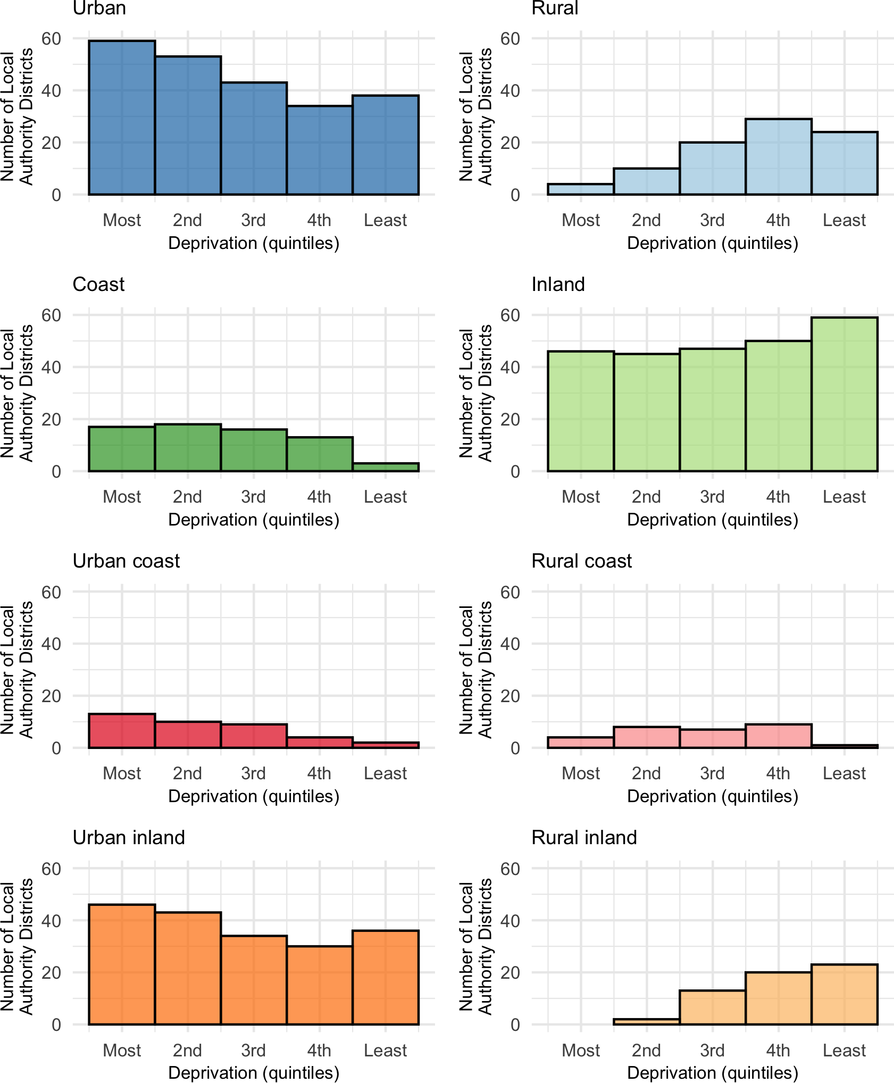

Appendix references
1. Bibby P, Brindley P. 2011 Rural-Urban Classification of Local Authority Districts and Similar Geographic Units in England: A User Guide 2017 [Available from: https://www.gov.uk/government/statistics/2011-rural-urban-classification-of-local-authority-and-other-higher-level-geographies-for-statistical-purposes.
2. Nazroo J, Marmot M, Oldfield Z, Steptoe A, Banks J, Blake M. English Longitudinal Study of Ageing: Waves 0-9, 1998-2019. [data collection]. In: Service UD, editor. 32 ed2020. 2020.
3. Nash A. Subnational population projections for England: 2016-based. UK: Office for National Statistics; 2018.
4. UK Government. The Somerset West and Taunton (Local Government Changes) Order 2018 No. 649. 2018.
5. UK Government. The East Suffolk (Local Government Changes) Order 2018 No. 640. 2018.
6. UK Government. The West Suffolk (Local Government Changes) Order 2018 No. 639. 2018.
7. UK Government. The Local Government (Structural and Boundary Changes) (Supplementary Provision and Miscellaneous Amendments) Order 2019. 2019.
8. Banks J, Batty GD, Nazroo J, Steptoe A. The Dynamics of Ageing: Evidence from the English Longitudinal Study of Ageing 2002–16 (Wave 8). 2018.

