Appendix A

Summary of Results

First Author Date Country

Design Setting

Sample Outcomes Measured Key Findings Factors Associated
with Frailty

Onen 2010 USA

Ness 2013 USA

Althoff 2014 USA

Chode 2016 USA
descriptive correlational

HIV clinic

St Louis, MO Jan 2008 to
Dec 2008

descriptive correlational, prospective subset

subset of St Jude Lifetime cohort

date not reported
descriptive correlational,
prospective interval

subset from a larger cohort study

four US cities Oct 2007 to
Sep 2011
descriptive correlational, longitudinal

St Louis, MO Sep 2000 to
Jul 2001, &
2010
N=445 patients seeking HIV+ related care

33-49 years
71% male
30% Caucasian
63% African American
N=2263 CCS (n=1922),
CCS subset (n=162)
control group (n=341)

18-60 years CCS subset at
baseline and 3.5 years
N=1946 MWHSWM

HIV positive (n=989)
control group (n=1048)

50-64 years
Maximum 8 visits

N=998
African Americans

DM (n=222)
control group (n=775) and

49-65 years
Baseline and 9 years
sociodemographic, frailty, risk behavior assessment, disclosure of HIV status, STI testing

chronic conditions, sex, race, cancer- related variables, BMI, social history, prior radiation, chemotherapy, surgery, frailty

demographics, depression screen, AIDS history, drug therapy, co- morbidities, inflammatory markers, HIV serostatus, CD4 T- cell count, viral load, frailty phenotype conversion

disability, function, physical performance, inflammatory markers, frailty

nine years later: new ADLs ≥ 1,
mortality
Frail individuals were older than non-frail.

Frail individuals were more likely to disclose HIV status to family than non- frail individuals.

Baseline frailty was associated with increased mortality risk and chronic condition onset.

Positive phenotype conversion among all men at all visits was 25%.
HIV positive: 12% positive phenotype conversion.
Control group: 9% positive phenotype conversion.

Frailty scores were ↑ for African Americans with DM vs control group.

Middle-aged African American with DM with ↑ frailty scores are at increased risk of 9-year mortality, falls in the previous year, and ADLs ≥1.
Physical:
age
Social:
HIV status disclosure to family

Physical:
age, abdominal/pelvic radiation, cranial radiation in females, BMI<18.5 or >39.9
kg/m²,
Psychological:
smoking

Physical: age, HIV positive, diabetes, kidney disease, hepatitis C
Social:
black race,
lower educational attainment
Psychological:
depressive symptoms, smoking

Physical:
diabetes, increased disability and functional limitations, higher cytokines (TNFR1 & TNFR2)

Hadenfeldt 2017
USA
descriptive, cross- sectional

Two free clinics in the Midwest

Jun 2014 to
Aug 2015
N=38
seeking medical care at free clinic

40-65 years
68% female
63% single
68% high school education or less
50% $0 to $500 monthly income
demographics, frailty Psychological, social
and environmental factors that may adversely affect health were identified.
Descriptive statistics only.

Palmer 2017
United Kingdom

Demircioglu 2018
Turkey

Griffin 2018 USA

Haider 2019
Austria
descriptive correlational, cross- sectional

Subset from a larger cohort study, adults registered with English general practices

2013 to 2014
descriptive correlational

outpatient HD clinic

Oct 2016 to
Nov 2016

descriptive correlational, longitudinal

secondary analysis of larger study (HANDLS)
in Baltimore, MD

Aug 2004 to
Nov 2008
descriptive, correlational
N=8095
community- dwelling adults

50-65 years
46% males
63.7%
unemployed

N=74
CKD patients receiving hemodialysis for at least 12 months

18-65 years
44.6% male
86% married
18% employed N=2541 urban-
dwelling adults

  - years
56% female
58% black
40% below 125% of the federal poverty limit Baseline and 6.6
years

N=100
seropositive RA patients

  - years
age, social class, employment status, employment related outcomes and perceptions, physical frailty symptoms, frailty

demographics, serum vitamin D, hemoglobin, albumin, parathyroid hormone, comorbidities, frailty

age, sex, race, poverty status, education, BMI, physical function, IADL, grip strength, self-rated health, polypharmacy, frailty

6.6 years later: mortality

sociodemographic, RA disease activity and duration, pain intensity, physical performance, meds,
Frailty symptoms were associated with unemployment, HRJL, sick leave, and not coping at work.

62% unemployed participants left their last job for health- related reasons.

Frailty score positively correlated with age.

Frailty was associated with low albumin, hemoglobin, and vitamin D levels.

Frailty was associated with the lowest average survival
>6.6 years, then prefrail, then non- frail.

Higher proportion of frailty in whites than blacks among aged 45-54 years.

Higher RA disease activity and longer duration, unemployment, higher pain intensity,
Social:
unemployment, sick leave, HRJL, adverse employment outcomes, not coping at work

Physical:
age,
lower vitamin D, lower hemoglobin,
lower albumin

Physical:
age, female gender, taking more than six medications, higher BMI
Psychological:
lower self-rated health
Social:
below poverty status, lower educational attainment

Physical:
higher pain intensity, higher RA disease activity and duration
Social: unemployment

Paolillo 2019 USA

Rubtsova 2019 USA

Salem 2019 USA
outpatient clinic in Vienna

Nov 2015 to
Aug 2016
descriptive correlational

subset from a larger cohort study, San Diego

enrollment date not reported

descriptive correlational

subset from a larger cohort study, San Diego

enrollment date not reported

descriptive correlational

four homeless shelters in CA

Feb 2015 to
May 2016
66% female
59% employed
71% married/in a relationship

N=210

HIV+/MA+ (n=43) HIV+/MA- (n=75)
control group (n=92)

35-65 years

N=127

People living with HIV (PLWH)
(n=65)
Control group (n=62)

35-65 years
80% male
53% Caucasian

N=130
homeless, formerly incarcerated, women

18-65 years
40% African American 46.9% high
school education
13.4% married
inflammatory markers, frailty

sociodemographic, HIV serostatus, psychiatric, frailty assessment, neurocognitive assessment, functional assessment

Sociodemographic, frailty assessment, psychosocial factors, biomedical variables, comorbidities

sociodemographic, psychologic factors, social factors, physical factors, frailty assessment
were associated with a higher frailty score.

Comorbid HIV+/MA+ group had higher mean FI scores than the HIV+/MA- group and the control group.

HIV+ groups displayed worse global and executive functioning than the HIV-/MA- groups.
Positive psychosocial factors reduced odds of frailty in all subjects.

Positive Resources/ Outlook were more strongly associated with decreased odds of frailty for PLWH than for HIV negative adults.
Frailty subscales (mean):
physical=2.0 (0-8), psychological=
1.7 (0-4),
social=1.1 (0-3)

Daily alcohol use was associated with less social frailty.

Physical:
HIV infection, comorbidities
Psychological:
methamphetamine use disorder

Physical:
HIV infection
Psychological: depression, higher perceived stress, lower grit, lower optimism, lower personal mastery
Social: higher number of negative interactions, lower social support
Physical:
older age, bodily pain
Psychological: drug use/dependency, depressive symptoms, increased emotional regulation difficulty, witnessed violence, PTSD symptoms
Social:
homelessness, jail/prison time, prior violence

Abbreviations: ADL, activities of daily living; BMI, body mass index; CCS, childhood cancer survivors; CKD, chronic kidney disease, DM, diabetes mellitus; HANDLS, Healthy Aging in Neighborhoods of Diversity across the Life Span; FI, Frailty Index; HIV, human immunodeficiency virus; HRJL, health related job loss; IADL, independent activities of daily living; MWHSWM, men who have sex with men; RA, rheumatoid arthritis; PLWH, people living with acquire immune deficiency syndrome; PTSD, post-traumatic stress disorder; STI, sexually transmitted disease; TNFR, tumor necrosis factor receptors.

Appendix B

Quality Appraisal Results

No | First Author | Year | Item 1 | Item 2 | Item 3 | Item 4 | Item 5 | Item 6 | Item 7 | Item 8 | Percent Yes
1 | Althoff | 2014 | N | Y | Y | Y | N | NA | Unclear | Y | 57% (4 of 7)
2 | Chode | 2016 | N | Y | N | Y | N | NA | Unclear | Y | 42% (3 of 7)
3 | Demircioglu | 2018 | Y | N | Y | Y | NA | NA | Unclear | Y | 67% (4 of 6)
4 | Hadenfeldt | 2017 | Y | Y | Y | Y | N | NA | Unclear | Y | 71% (5 of 7)
5 | Haider | 2019 | Y | Y | Y | Y | NA | NA | Unclear | Y | 83% (5 of 6)
6 | Griffin | 2018 | N | Y | Y | Y | Y | Y | Y | Y | 88% (7 of 8)
7 | Ness | 2013 | N | Y | Y | Y | N | NA | Unclear | Y | 57% (4 of 7)
8 | Onen | 2010 | N | Y | Y | Y | N | NA | Unclear | Y | 57% (4 of 7)
9 | Palmer | 2017 | N | Y | Y | Unclear | NA | NA | N | Y | 50% (3 of 6)
10 | Paolillo | 2019 | N | Y | Y | Y | N | NA | Unclear | Y | 57% (4 of 7)
11 | Rubtsova | 2019 | N | N | Y | Y | N | NA | N | Y | 42% (3 of 7)
12 | Salem | 2019 | Y | Y | Y | Y | NA | NA | Y | Y | 100% (6 of 6)

Quality appraisal results using the Joanna Briggs Institute checklist for analytical cross-sectional studies [25].

Appendix C

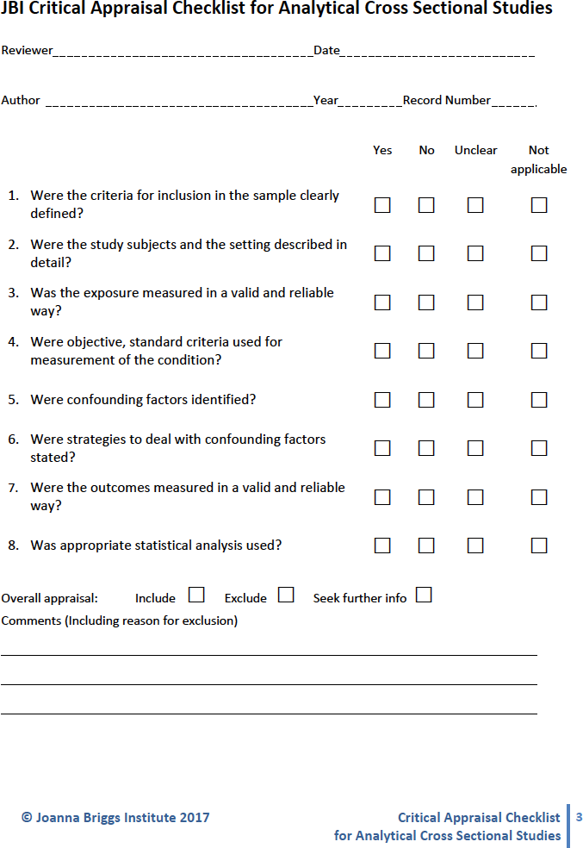

Appendix D

Study Purpose, Frailty Measure(s), and Frailty Prevalence

First Author Year
Study Purpose Frailty
Measure(s)
Prevalence of Frailty and Prefrailty

Onen 2010

Ness 2013

Althoff 2014
Chode 2016

Hadenfedlt 2017
Evaluate differences in sexual behaviors and prevalence of sexually transmitted infections between frail and non-frail HIV-infected individuals in a clinic population.
Estimate prevalence of frailty among adult childhood cancer survivors and examine associations with current and future morbidity and subsequent mortality.
Examine the relationship of frailty and aging with HIV.
Examine the associations of diabetes with frailty on health outcomes in a middle-aged African American population.

Determine if factors suggestive of frailty were present in adults ages 40 to 64 years who received care in a free clinic.
*Fried’s
criteria

*Fried’s
criteria

*Fried’s
criteria
†FRAIL
‡SOF
Fried’s criteria Frailty Index
§CFAI
Fried’s criteria
7 researcher - generated questions
9% (39 of 445) Frail
... Prefrail

11% (125 of 1122)
Frail
28% (314 of 1122)
Prefrail
...

...

§CFAI:
63% (24 of 38) Frail
11% (8 of 38) Prefrail Fried’s Criteria:
13% (5 of 38) Frail
55% (21 of 38) Prefrail

Griffin 2018
Examine association of race and poverty with
†FRAIL scale scores and how sex, race and poverty may modify the relationship of frailty and survival.
*†FRAIL 11% (278 of 2541)
Frail
36% (924 of 2541)
Prefrail
Palmer 2017
Assess the prevalence and relationship of symptoms of physical frailty and explore their
*Fried’s
criteria
3.9%
Frail
(313 of 8095)

Demircioglu 2018
associations with various adverse employment outcomes.
Investigate the frequency of frailty and the association between vitamin D levels and the frailty phenotype among non-geriatric dialysis patients.

Fried’s criteria
31.6% (2560 of 8095)
Prefrail
53% (39 of 74) Frail
18% (6 of 74) Prefrail

Haider 2019

Paolillo 2019
Assess the prevalence of prefrailty and frailty and the associated demographic and clinical factors in seropositive rheumatoid arthritis patients of working age.
Study lasting effects of past methamphetamine use disorder on frailty among middle‐aged to older people living with HIV.
¶SHARE-FI 15% (15 of 100) Frail
30% (30 of 100)
Prefrail

*Frailty Index ...

Rubtsova 2019
Assess association between multiple psychosocial factors and frailty phenotype as
*Fried’s
criteria
50% (64 of 127) Frail
... Prefrail

Frailty in Young and Middle-Aged Adults

Salem 2019
measured by the Fried Frailty Index among people living with HIV.
Explore physical, psychological and social frailty among formerly incarcerated, currently homeless women.

Tilburg Frailty Indicator

...

*Tool or tool criteria was adapted to meet the needs of the study or sample.
†The International Academy of Nutrition and Aging frailty scale measuring fatigue, resistance, ambulation, number of illnesses, and loss of weight.
‡Study of Osteoporotic Fractures frailty scale
§Comprehensive Frailty Assessment Instrument
¶Frailty Instrument for Primary Care of the Survey of Health, Ageing and Retirement in Europe
Abbreviations: HIV, human immunodeficiency virus

Frailty in Young and Middle-Aged Adults

