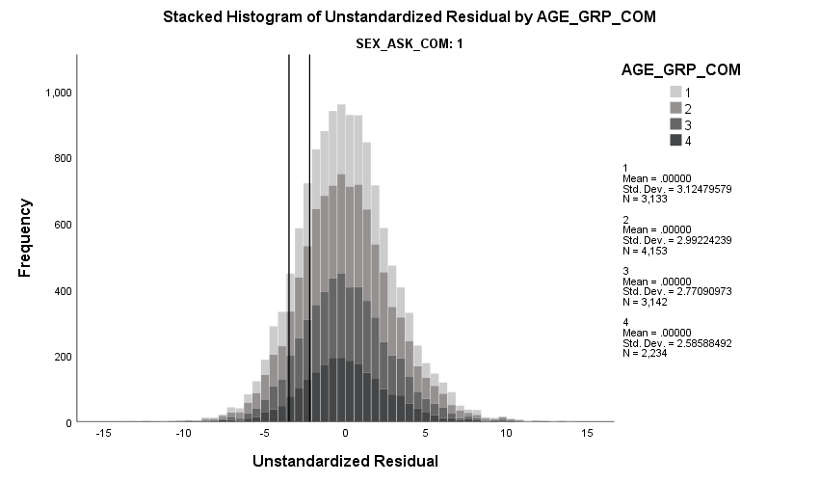

-3.51 cut off (residuals not age stratified)

-2.23 cut off (age stratified residuals)

**45 to 54 years**

Mean: 1.36

Standard deviation: 3.13

**55 to 64 years**

Mean: 0.50

Standard deviation: 3.00

**65 to 74 years**

Mean: -0.63

Standard deviation: 2.79

**75 to 85 years**

Mean: -1.95

Standard deviation: 2.63

**Age group**

**Figure 1a –** Residual values of muscle mass regressed on height2 and fat mass in males by age group when the residuals are calculated in all participants

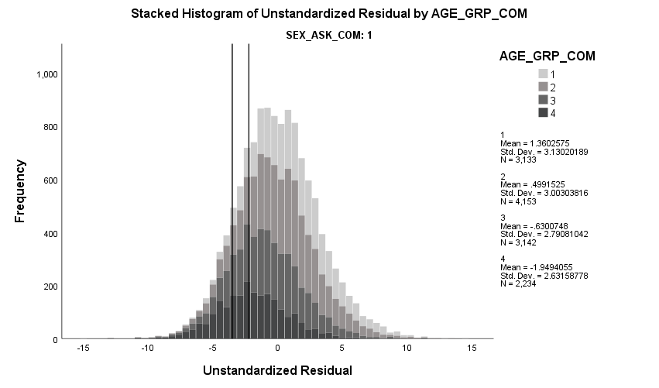

-3.51 cut off (residuals not age stratified)

-2.23 cut off (age stratified residuals)

**45 to 54 years**

Mean: 0.00

Standard deviation: 3.13

**55 to 64 years**

Mean: 0.00

Standard deviation: 2.99

**65 to 74 years**

Mean: 0.00

Standard deviation: 2.77

**75 to 85 years**

Mean: 0.00

Standard deviation: 2.59

**Figure 1b –** Residual values of muscle mass regressed on height2 and fat mass in males by age group when the residuals are calculated after age stratification

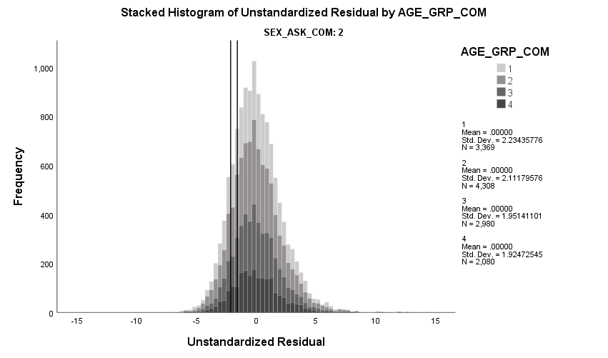

-2.15 cut off (residuals not age stratified)

-1.58 cut off (age stratified residuals)

**Figure 2b –** Residual values of muscle mass regressed on height2 and fat mass in females by age group when the residuals are calculated after age stratification

**Figure 2a –** Residual values of muscle mass regressed on height2 and fat mass in females by age group when the residuals are calculated in all participants

**45 to 54 years**

Mean: 0.84

Standard deviation: 2.24

**55 to 64 years**

Mean: -0.01

Standard deviation: 2.12

**65 to 74 years**

Mean: -0.46

Standard deviation: 1.96

**75 to 85 years**

Mean: -0.67

Standard deviation: 1.95

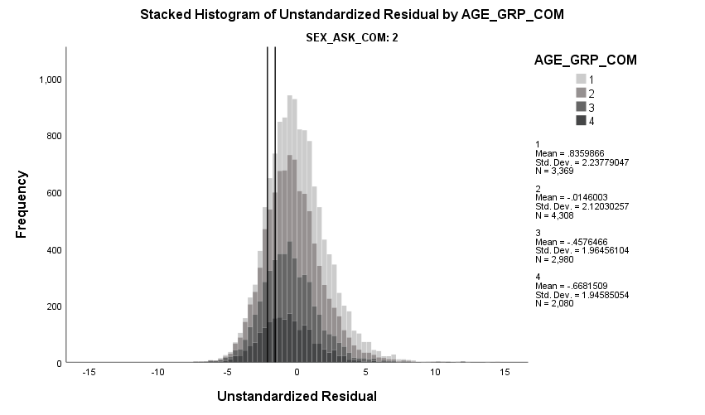

-2.15 cut off (residuals not age stratified)

-1.58 cut off (age stratified residuals)

**45 to 54 years**

Mean: 0.00

Standard deviation: 2.23

**55 to 64 years**

Mean: 0.00

Standard deviation: 2.11

**65 to 74 years**

Mean: 0.00

Standard deviation: 1.95

**75 to 85 years**

Mean: 0.00

Standard deviation: 1.92