Authors
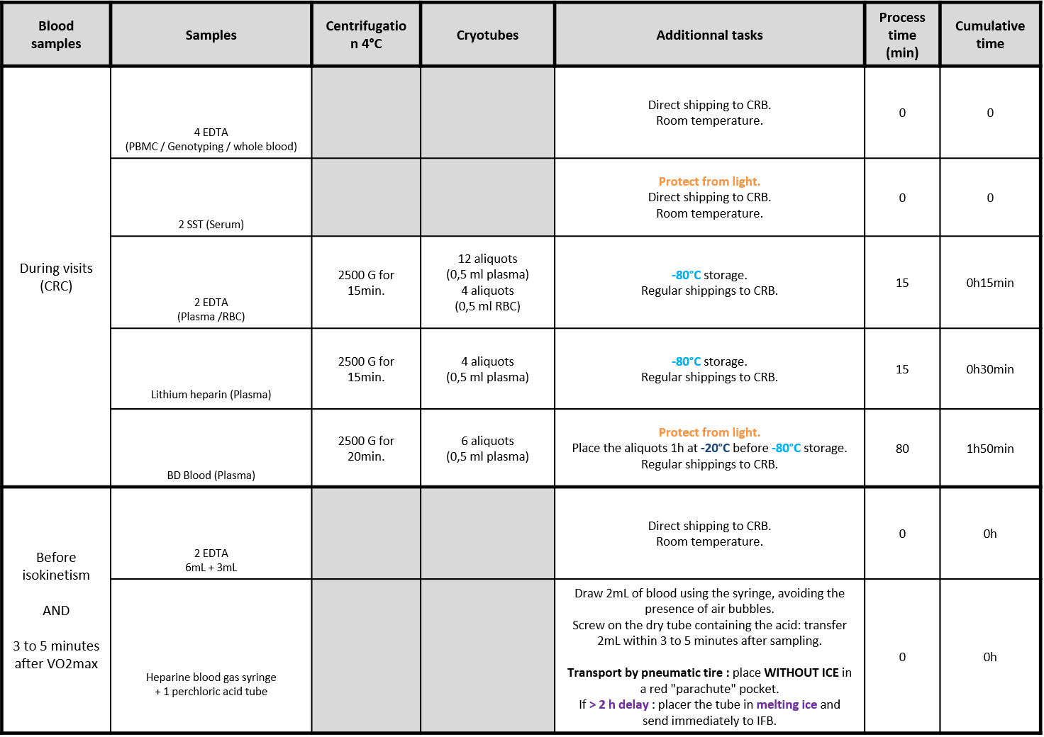
ONLINE CONSULTATION - Figure 2. Laboratory procedures for preparation of biological material (blood samples)

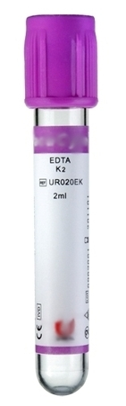

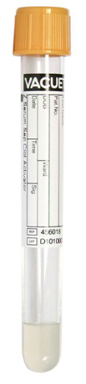

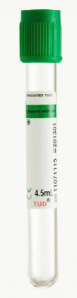

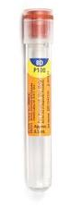

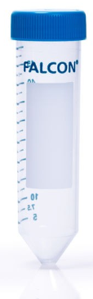
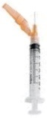

ONLINE CONSULTATION - Figure 3. Laboratory procedures for preparation of biological material (skin, dental plaque, saliva, urine, nasopharyngeal)
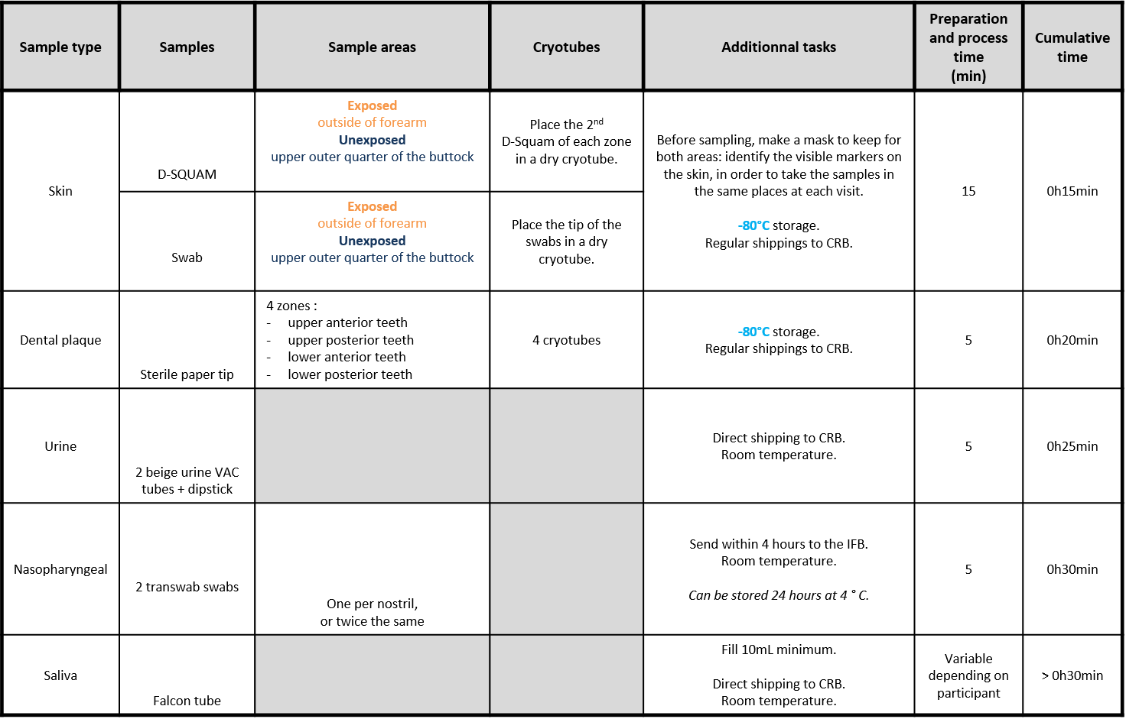
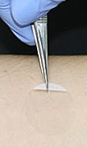
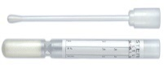
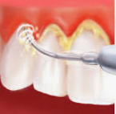
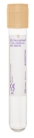
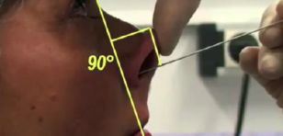
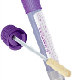

ONLINE CONSULTATION – Figure 1. Organizational chart describing the various study components of the INSPIRE-T cohort

Scientific Committee of
the INSPIRE Program

Financial Management Team
Regulatory Management Team
Legal Management Team
In charge of :
1/ Conduction of the study :
Recruitment and retention of subjects
Clinical, biological and digital collection
Remote monitoring of IC
2/Implementation of the standardized operational procedures
3/ Preventive strategies to ensure data quality
Technical and operational forms
Biological Resource Center « CRB TBR » (supervision of the INSPIRE-T biobank)
Clinical Research Imaging (supervision of imaging data)
University sports Clinic (supervision of cardiorespiratory fitness exploration)
Clinical Research Center (CRC)/ Research mobile team
Unity of support in research methodology
Project Management Team of the INSPIRE T Cohort

